Case Study – Sport and Physical Activity Review
This research was designed to investigate attitudes and behaviour around physical activity and exercise in general, and more specifically to find out about opinions around, and awareness of, North East Lincolnshire Council’s leisure centres, parks, open spaces and waterfronts. Finally, the aim was to look at what would encourage people to use these leisure facilities in the future.

The review aimed to gain an understanding of:
- Experience of the current provision from the viewpoint of the service user and their carer(s); including:
- What is working well
- What could be improved
- If the service is meeting the needs of carers
- Whether there is an appetite for more community-based Day services and activities, rather than the current service which is predominantly based within Centres.
- How service users and the public currently access information about Day services.
- The method of transport being used by service users to access Day centres
- How service users and their carer(s) adapted to the restrictions which were implemented in response to the Covid pandemic; when in many cases, Day centres were closed for several months, or operating with reduced capacity.

Leisure-net Solutions, were commissioned to carry consultation and research on this project out on behalf of North East Lincolnshire Council. Leisure-net Solutions also worked with NELC Research & Engagement team to gain support and access to local people, groups and organisations to help facilitate routes into community members it was found harder to reach to and to help the organisation of local focus groups.

Research Methods
The data within the report was gathered using an online survey. The survey was completed in October 2022. Please note that this online survey was a self-selection online survey, with a sample size of 420. In commissioned organisations experience it is likely to be completed by residents with a stronger view on local provision/service, who are also likely to be more active and/or involved or have an interest in local provision, such as sports centres, sports clubs etc. The survey was advertised to local residents through a variety of means, including the Council’s social media channels, the local VCS sector bulletin via Sector Support, through NELCs weekly consultations email and on NELCs Have Your Say webpage.

Summary of methods used;

  - Online survey – Links shared via NELCs social media, consultations webpage and weekly email to registered cohort as well as inclusion within weekly VCS newsletter.
  - Direct engagement - Visited partner organisations groups/classes to access harder to reach demographics.
  - Focus groups – Utilised existing relationships to engage via coordinated focus groups to allow more in-depth discussions.
It is important to not only use surveys and online engagement to reach further but also ‘going to where people are’ by utilising the great networks and relationships we have amongst local partner organisations.

Results/response Overview
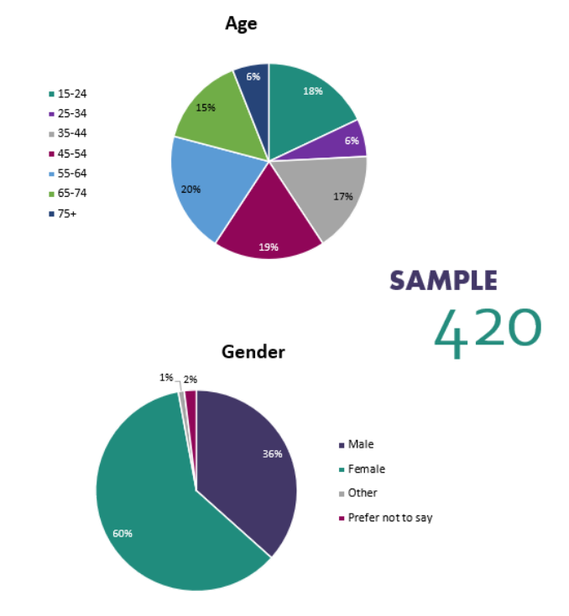
The above spread of age demographics shows that varying the styles of engagement allows a greater cross section of ages to be reached (eg not simply online but also ‘face to face’ in places groups are) thus allowing a better informed piece of engagement not skewed by only using a younger audiences feedback alone.

