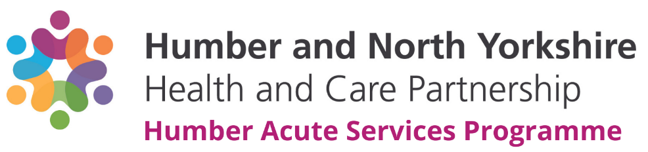

Engagement – Examples of good practice
Involving and engaging stakeholders from across the region has played a crucial role in the success of the Humber Acute Services Programme since its inception in 2018, and more currently in developing the potential models of care currently being evaluated by the Programme team.
The involvement methods and approaches we have used have had to adapt and change in response to the COVID-19 pandemic and the restrictions that were put in place to control the spread of the virus. This changing context created both challenges and opportunities for the programme.
We would like to share a few examples of what we deem to be ‘good practice’ engagement.
1 – What Matters to You
The Humber Acute Services Programme is working to develop solutions and potential options for the future design of hospital services. A key element of success for the programme is the development of a robust process for evaluating and appraising the potential options for change. The What Matters to You engagement programme was designed to support the development of the options appraisal process.
The aim of the engagement was to gather the views of staff, patients, the wider public and other stakeholders to ensure the decision-making process is informed by a range of views and opinions.
A range of methods were utilised in order to gather the views of a range of stakeholders, including an online questionnaire containing a mix of qualitative and quantitative questions. The key question being a ranking question where participants were asked to rank the nine decision-making criteria in order of importance to them. Public friendly definitions were developed collaboratively with the Programme’s Citizen’s Panel to ensure accessibility and understanding.
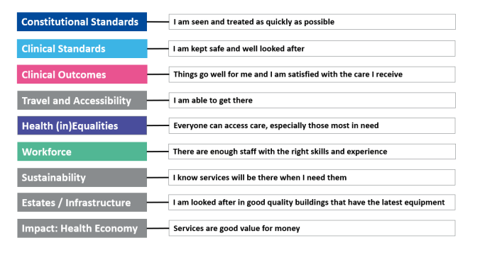

To supplement the feedback gathered through the survey, we also undertook a series of workshops to engage directly with the following stakeholder groups:
- Citizen’s Panel
- Hospital Trust Governors
- Hospital Trust Non-Executive Directors
- Local Councillors.
A comprehensive promotional and communications plan was developed, and its delivery was supported by Communications and Engagement Delivery Group (representation includes, CCGs, Trusts, Healthwatch, Ambulance), Primary Care and VCSE organisations across the Humber.
The engagement was extremely successful with 3883 people responding to the online questionnaire, and 63 stakeholders attending the focus groups, and through this engagement we heard that being seen and treated as quickly as possible was most important to people.
We learnt a lot from this engagement and where responses from some communities and groups were particularly low, we adapted our process of listening to target these groups, making connections with a charity supporting sex workers in North East Lincolnshire, youth centres in deprived areas of Goole and local authority workers in North East Lincolnshire supporting homeless people. We also developed a bespoke engagement activity booklet to hear from more children and young people. (described further in point 2)
In addition, we re-opened the questionnaire later in the year to allow anyone who had not yet responded to have their say, and to see if people’s priorities changed as more information relating to the review was made available.
In response to comments left by staff members, we created a bespoke internal questionnaire for our workforce to share their views and perspectives, followed by a series of workshops to discuss the feedback in more detail.
Finally, we also ensured that the What Matters to You ranking question was asked in all our other engagement on specific services.
The feedback and summary reports for What Matters to You and What Matters to You- Revisited can be found here: https://humbernorthyorkshire.engage-360.co.uk/

2 – Children and Young People
This engagement exercise was developed in response to the What Matters to You engagement described above, participation from children and young people was low.
To ensure that the voices of children and young people were heard, throughout November and December 2021, we undertook a targeted engagement exercise with children and young people across the Humber to hear what they liked and didn’t like about coming into hospital and what was most important to them when receiving care or treatment to help them feel better quickly.
To undertake this engagement effectively and ensure young people could respond in a way that was meaningful to them, a child-friendly approach was developed in partnership with play specialists, patient experience leads and paediatric clinical leads within the two trusts. The Programme’s Citizen’s Panel also played a key role in coproducing our approach.
For young children (aged approximately 0-10 years) a fun activity booklet was developed featuring drawings, matching activities ad space to write or leave comments.
For older children/young people (aged approximately 11-18 years) a bespoke questionnaire was produced with simplified questions and open space to provide free text or drawings. This booklet was also available to complete online and a URL and QR code was provided to participants. Participation was incentivised with a prize giveaway and parental consent was built into the survey design.
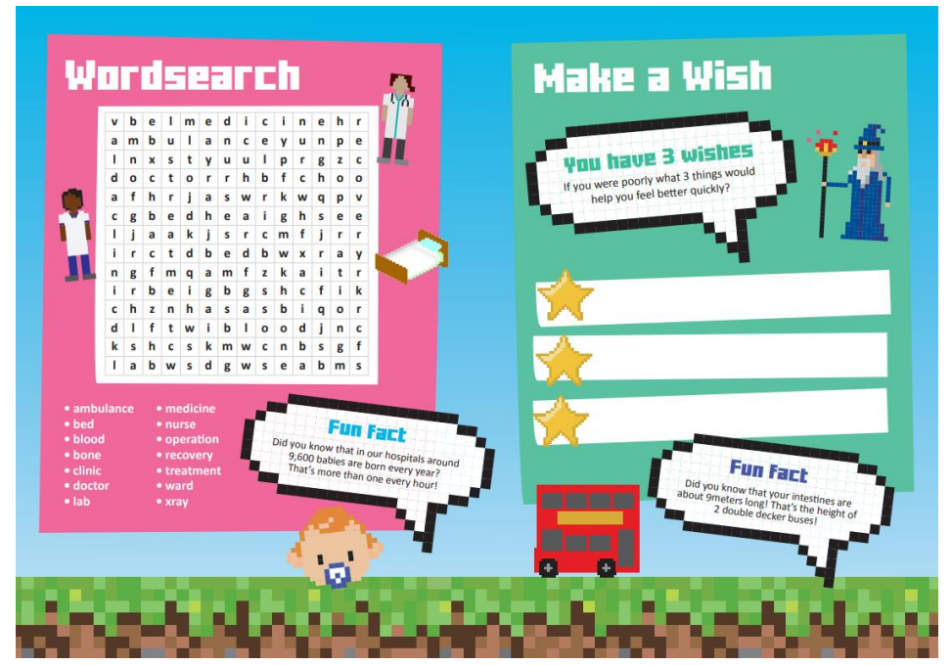
Both resources were thoroughly tested by a reference group of children and young people of a variety of ages to ensure accessibility and appropriateness.
Patient experience teams and nurse specialists within both trusts delivered the engagement activity to ensure any patients coming onto the paediatric wards at Hull, Grimsby or Scunthorpe had the opportunity to take part. In addition, an online survey was promoted via social media and other channels (e.g. staff and stakeholder newsletters), targeted particularly at parents, carers and guardians seeking their support to enable their children to take part.
Additional offline methods were also used to reach out to children and young people in more deprived communities and who might face barriers to access, for example a number of copies of both booklets were posted to local youth club providers working in areas of high deprivation to distribute on our behalf.
Running alongside this engagement activity was an opportunity for parents, carers and guardians to get involved and share, from their perspective their experiences of accessing paediatric and other hospital services in the Humber. Utilising the ‘What Matters to You’ survey, we created a bespoke communications campaign to promote this opportunity to parents, carers and guardians across the Humber, including small business cards being handed out with the children and young people’s engagement booklets.
In total, we heard from 63 children and young people and 277 parent, carers and guardians.
The booklets developed for the children and young people are attached to the email. The feedback report is due to be published within the next couple of weeks.

3 – Your Birthing Choices
The ‘Your Birthing Choices’ engagement exercise was undertaken to understand what is
important to women & birthing people, birthing partners and support people when choosing where to
give birth; what are their main concerns around the different birthing options (home births,
midwife-led births and hospital births) and what could be put in place to alleviate those
concerns.

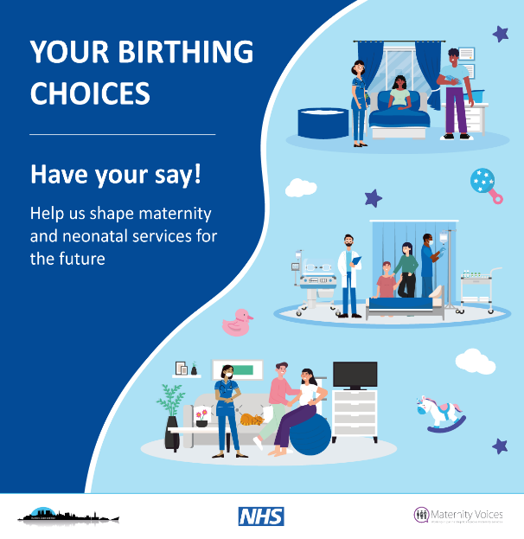
At the time, both the Humber Acute Services Programme and Scarborough Acute Services Review were working to develop solutions for the future design of maternity and neonatal services, so to avoid duplication, the engagement activity took place across the entire Humber, Coast and Vale area. This collaborative approach would allow for a better understanding as to what is important to our population as a whole.
A working group was formed and MVP chairs from all six MVP’s were invited to join. Lincolnshire MVP was also invited given the number of women and birthing people who travel into the Humber area from Lincolnshire to give birth. LMS representatives were also invited as were families with lived experience of neonatal care. The group met 3 times and coproduced the approach, communications plan, social media content, questionnaire, creative assets and animation. They helped ensure service user feedback was gathered by testing materials with friends and MVP members as well as with clinical staff and midwives.
The outcome was an engagement exercise and suite of resources which had been fully coproduced and that the group felt proud of.
Feedback was gathered via an online questionnaire, with paper copies and alternative language/formats available upon request. In addition a series of experience and views workshops were hosted targeting specific groups, including:
- Families with neonatal experience
- Young families
- Birthing people from an ethnic minority background
- Dads, Step-dads and partners.
In total 1,133 people completed the questionnaire and 3 people attended the workshops, all from an ethnic minority background.
The feedback report is due to be published within the next couple of weeks.
Please click the link to view the animation: https://www.youtube.com/watch?v=aptrxmBkIaw&t=5s

For any further information, please contact Samantha.thompson46@nhs.net

