Case Study – involving community members in LiveWell website

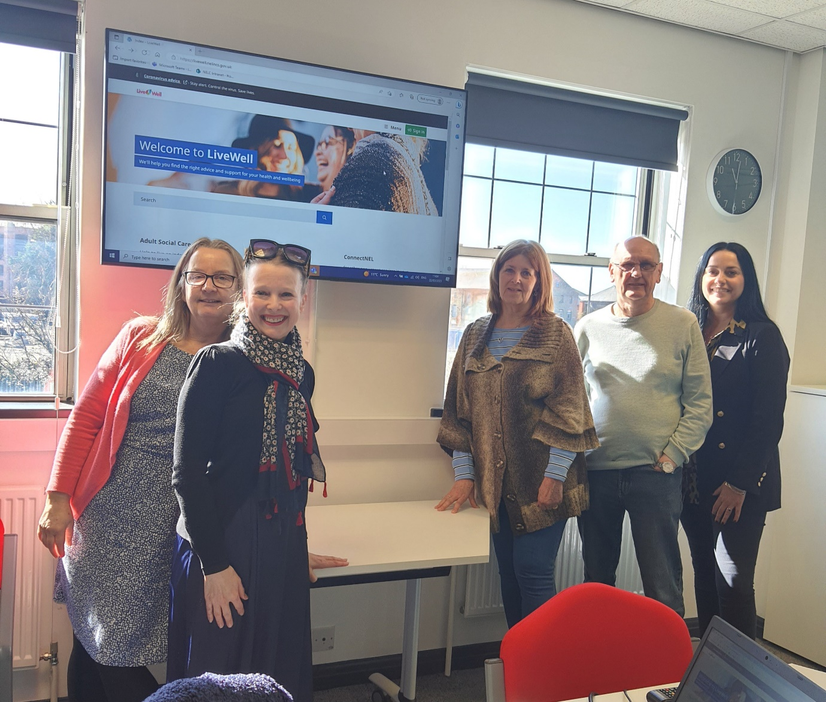

The LiveWell site https://livewell.nelincs.gov.uk/ hosts information and advice about health, care and wellbeing. Acting as a ‘digital front door’ LiveWell is an essential mechanism for ensuring that locally relevant knowledge is always available.
Staff from the Council and ICB worked together with ACCORD members to review and update areas of the LiveWell site. The group worked on a range of topics in conjunction with subject matter experts. For example, a new area was created offering guidance on paying for adult social care with support from the Finance Team at Focus Independent Adult Social Work, and a new page was created on access to advocacy in conjunction with Cloverleaf Advocacy.
Overall, the group’s objective was to make sure that LiveWell offers useful advice to local people, in language that is accessible.
Input from ACCORD members was crucial in anticipating the kind of information that those potentially in need of health and care might want, and responding to that with user-friendly, easy to find help.

