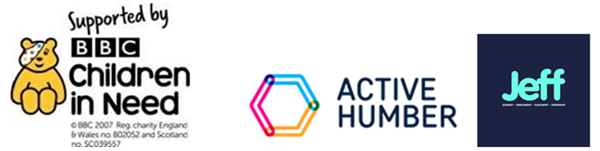

Case Study - Go Wild Go Free
This is the name of Creating Positive Opportunity's Children in Need project. This exciting programme offers after school activities and school holiday trips to children who may not have the opportunity to enjoy events that other families take for granted.
This project was developed through co-production with children, families, early help partners at NELC, through conversations with Young and Safe and with other VCSE providers.
Most importantly we listened to children who engaged with us on a Covid Children in Need project, managed by Active Humber. The responses we got were telling and at times heart breaking. “I’d like to do stuff the other kids in my school do, like going to a theme park or Go Ape, but we can’t afford it.” After school I have nothing to do, my mum never has time to take me anywhere or do anything.” “I’ve never been to the beach.” What’s a picnic?” !’d like to make new friends and maybe have the chance to go away somewhere different.
In the first 12 months of this project Creating Positive Opportunity have engaged with 59 young people aged 5-18, against a target of 48. We hold an afterschool club for two hours every Tuesday, on the Nunsthorpe Estate. We run activities and residentials throughout half-term, Easter and summer holidays, and quite simply we have delivered what our children asked for.

Reporting back on our project the BBC stated:
“Thank you for submitting this report. It was lovely to read about how the project has gone this year, I particularly enjoyed the emphasis on providing friendships in outcome one. It is clear that you treat each cyp as an individual and work thoughtfully to enable them to be the best they can be, and the case study was a powerful example of this. Your monitoring and evaluation was simple and effective. Congratulations on a successful year of delivery.”

Whilst it is always rewarding to receive such feedback, we feel that this reflects upon a project devised and delivered through genuine engagement and co-production.
Creating Positive Opportunity are now offering this project to referrals from the JEFF project – partners are NELC Young and Safe, Compass Go and We Are With You.

For more information contact fiona@mycpo.co.uk

https://www.mycpo.co.uk/

