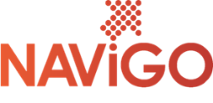
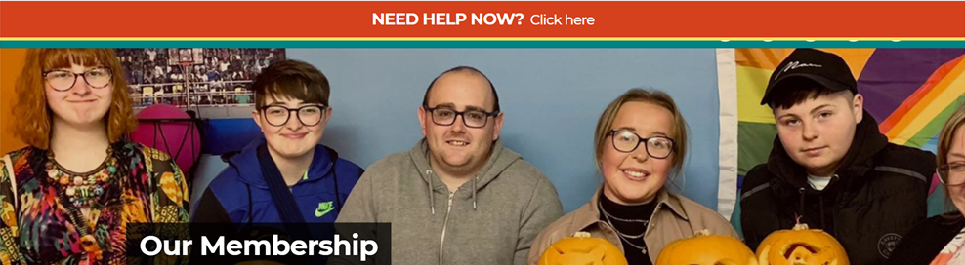
NAViGO Community Membership.
NAViGO community members directly influence how local mental health care in North East Lincolnshire is delivered.
Our active membership is one of the things that makes us unique and we can’t improve our services without understanding and listening to the people who use them (and their carers!).
Our members can attend our AGM every year, where we invite guest speakers, celebrate achievements, give out awards.
Community members have the chance to put forward a ‘Project of the Year’ – an idea that fills a gap in the market in mental health provision in North East Lincolnshire. Members and staff then vote for their favourite at the AGM and NAViGO fund the winner for 12 months - Safespace, Simply You and NAViGATE all began as Project of the Year proposals!
Community members also help shape our yearly objectives – the things we need to focus on over the next 12 months and they take part in project development and focus groups across our services.
They also sit on interview panels when we’re looking to add to the NAViGO team, helping us to decide who we employ. And, they can even nominate themselves to become a community representative – a key role in making sure we’re listening to service users and their experiences.
As a community member they can take advantage of dozens of discounts at North East Lincolnshire businesses including coffee shops, gyms, restaurants, salons, florists and more.
Membership Representatives.
Every two years, the membership elect five community representatives and five staff representatives. They sit on our membership board and help shape the future of NAViGO, and have voting rights on how we spend money and what projects we focus on.
Community representatives are the voice of service users and the wider community. Staff representatives act in the interests of our employees.
The community representatives are the community member’s direct line to the senior management team. If members have any concerns or positive feedback, they can contact the representatives and they will make sure the right people understand and take into account those views and put change into action.
From the ten reps, one community rep and one staff rep put themselves forward as Non-Executive Directors, or NEDs. The BAME staff representative also acts as a NED. The NEDs sit on our CIC Board, which makes important choices about which projects and services to prioritise. Reps can be elected for a maximum of two, two-year terms.

Membership Board
Staff and community representatives sit on the Membership Board alongside our senior managers.
Taking place once a month, the meeting gives the representatives the chance to raise any issues directly with managers. This is a public meeting and we encourage our community members to attend.
Membership Board also report directly to CIC Board, so our board of directors can keep up-to-date with developments within the membership.

Community Member Feedback
Taking place on the second Friday of each month, we hold Your Voice. It’s our community members’ chance to help shape local mental health services in a friendly, relaxed atmosphere.
We share all the latest news, developments and events from across NAViGO and offer the opportunity for members to tell us what we’re doing well – and where we can improve.
Each month, we have guest speakers from both inside and outside the organisation who will pass on all the information that our members need to know about what’s going on across North East Lincolnshire.
The membership reps also attend Your Voice, so our members can pass on any feedback or concerns to them.
But at NAViGO, we understand that some members may not feel comfortable speaking out at meetings or forums so we also run both paper and online surveys for important topics such as gatherting feeback about our yearly objectives, membership awareness and inviting proposals for the development and usage of our latest site acquisition, The Grange.
Examples of our surveys can be accessed by clicking on the following links:
Community Membership Survey NAViGO Objectives Survey

