Understanding Cultural Intelligence (CQ), intercultural, and cultural competence, Allyship and related anti-oppressive practices toolkit

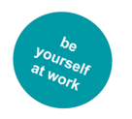

Also supporting North Lincolnshire Council’s Diversity, Equality and Inclusion Strategy and Allyship Programme - Toolkit compiled by Liesel Dickinson (pronouns she/ her)

Title | Page
Introduction | 3
Part One –General and transferable concepts and understanding for culturally intelligent, inclusive practice and leadership | 4
Setting the scene – professional responsibility | 4
Anti-discriminatory practice and Thompsons PCS Model | 4
Social Work Standards | 4
What is cultural Intelligence (CQ) and how does it relate to cultural and intercultural competence | 5
Cultural intelligence and social work practice | 6
The importance of cultural intelligence in the NHS | 6
Intercultural competence | 6
Culture competence | 7
What cultural intelligence, intercultural and cultural competence have in common | 7
Understanding intersectionality (A need to work intersectionally) | 8
Allyship | 9
The allyship journey applying a growth mindset | 10
The goal is to become capable not comfortable – eight questions to support allyship in practice | 11
Understanding privilege | 11
Understanding unconscious bias | 12
Micro behaviours, microaggressions / micro-inequities | 14
Emotional labour (tax) | 15
‘Passing’ / Covering a survival strategy | 15
Language matters | 15
Part two Characteristic specific understanding promoting anti-oppressive, culturally intelligent and inclusive practice and leadership – includes ways to be an active ally | 21
Disability and anti-ableist approaches in practice (includes an exploration of ableism and internalised ableism, social work specific articles relating to ableism and social work and six ways to be an ally) | 21
Race and anti-racist approaches in practice (includes an exploration of race and the types of racism, the danger of a single story and six ways to be an ally) | 25
Sexual orientation (including people who might identify as ACE) and, anti-homophobic, anti-biphobic and other related anti-discriminatory approaches and practice (includes information about the ways homophobia and biphobia can manifest and six ways to be an ally and terminology related to sexuality including ACE sexualities) | 30
Gender identity, anti-transphobic and related anti-discriminatory approaches and practice (includes information about the ways transphobia can manifest, five ways to be an ally and terminology relating to gender identity and expression) | 34
Research in Practice Equity, Diversity and Inclusion Resources | 41

Introduction
The aim of this toolkit is to equip the workforce with skills and knowledge around cultural intelligence (and understanding the difference between cultural intelligence intercultural and cultural competence) to enable, active allyship, understand manifestation of privilege and be able to check and mitigate our conscious and unconscious biases to support people who may face disadvantage, discrimination, harassment (or bullying) micro behaviours and microaggressions due to disability, race, sexuality, gender identity or other diversity factor/s or intersection of.
Links to articles, videos and podcasts are provided throughout the document to support ally learning. – Working around issues of cultural intelligence, allyship and inclusion, requires empathy, self- awareness and for us to step out of our comfort zone, it may trigger biases – biases we didn’t know we had. Being active in our allyship will challenge us (for example negotiating conflicting needs within a family or team) and may make us feel vulnerable . It will, promote understanding and new learning (and that might involve making mistakes,) making for more effective and inclusive outcomes and experiences. As we become more confident in our allyship and developing cultural intelligence, we can develop an understanding of impact of power dynamics and, the nuances and intricacy of inclusive working practice and leadership.
It is important to demonstrate a cultural intelligence and allyship first to all our colleagues and particularly to be aware of the additional emotional labour, triggers, disadvantage, discrimination, micro behaviours and microaggressions, colleagues with minority lived experiences do experience (endure) including, from colleagues and customers. – It is important to be an ally so that when reasonable challenge is required, appropriate action is taken (proactively.)
Unacceptable behaviour example: A racist slur is made by a customer, both the black and white colleague working with the customer hear the racist comment. Active allyship requires the white colleague to support their black colleague, to make a challenge and / or take appropriate action. This will enable their black colleague to feel safe and supported and ensure that emotional labour for the black employee isn’t further compounded by a colleague / team who remain silence.
It is important to demonstrate a cultural intelligence and allyship to all customers. – To be particularly aware of the additional emotional labours, triggers, disadvantage, discrimination, micro behaviours, microaggressions, internalised discrimination and other barriers, customers with minority lived experiences endure on a regular basis. It is important to understand this, as it may impact on the interaction / trust issues a customer has when working with you [and it should not to be taken personally] For example a customer with lived experience of disability, may have experienced institutional ableism. Allyship and cultural intelligence enable continuing learning, so we do not perpetuate the barriers and discrimination or further trigger or contribute to the customer’s internalisation of discrimination.

Part One –General and transferable concepts and understanding for culturally intelligent, inclusive, anti-discriminatory practice and leadership

Setting the Scene – professional responsibility
The Equality Act 2010 underpins all professional equality responsibilities to:
- Eliminate discrimination, harassment and victimisation
- Advance equality of opportunity [that can include for example the use of positive action in employment and or provision of services]
- Foster good relations between different parts of the community

See the Equality and Human Rights Commission Website for more information and guidance.
Aware that poverty does disproportionately impact on certain groups for example, disabled people are five times more likely to be at risk of food poverty and more likely to be living in poverty because of the barriers to life chances and the extra costs relating to disability
Disabled People Five Times More At Risk Of Food Poverty |
These risks are compounded by intersection [see page 8]
In recent times, organisations have been revisiting the socio-economic duty, part of the original Equality Act proposals
A Practical Guide for Local Authority Implementation of the Socio-Economic Duty in England (gmpovertyaction.org)
Working in social care, we have a professional responsibility to ensure professional standards and ethics are embedded within our practice and professional conduct.

Anti-discriminatory practice
Anti-discriminatory practice refers to “how individual operate in a way that fights practices and behaviours which are discriminatory in nature. It also involves practices which promote social justice” (Thompson)
Thompsons PCS (personal, cultural, structural) model “attempts to explain how discrimination can occur on three separate but interrelated levels; personal, structural and cultural level. The interaction between discrimination and oppression can be seen through structures and systems within the economy”

Social Work professional Standards
- 1.5 Recognise differences across diverse communities and challenge the impact of disadvantage and discrimination on people and their families and communities.
- 1.6 Promote social justice, helping to confront and resolve issues of inequality and inclusion.
- 3.14 Assess the influence of cultural and social factors over people and the effect of loss, change and uncertainty in the development of resilience.

BASW Code of Ethics (Updated, 2021)
- 2.1 Human Rights: Promoting the right to participation; treating each person as a whole.
- 2.2 Social Justice: Challenging discrimination; recognising diversity.

What is Cultural Intelligence and how does it relate to Intercultural and Cultural Competence?
Cultural intelligence (CQ) is a measure, around competency, other measures include IQ (Intelligence Quotient) and Emotional intelligence (EQ) Richard Levychin identifies
“Having a high EQ, which stands for emotional quotient and measures one’s ability to connect to people on an emotional level, combined with hard work and a high IQ used to be enough, but it is also no longer sufficient to lead to professional success.
Today’s and tomorrow’s professionals will also have to own a high CQ, a measure of cultural intelligence and the ability to interact comfortably and successfully with other cultures. Studies have shown that people with a high CQ perform better on multicultural work teams than those with a low CQ.”
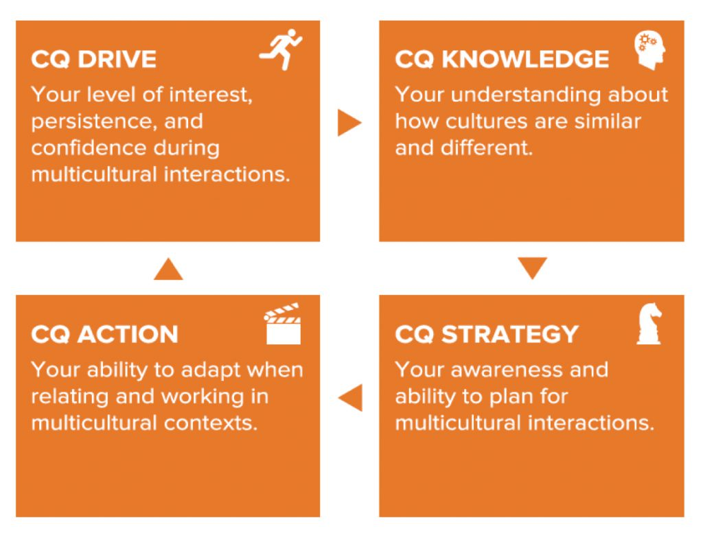
Illustration from the Cultural Intelligence Centre Website

[Illustration description, the CA model is explained with 4 boxes – background orange with white text. The first box reads: CQ Drive with an icon of a running man in the right corner the text reads: Your level of interest, persistence and confidence during multicultural interactions. An arrow points to the next box on the right. The text in the box reads: CQ Knowledge with an icon of a head in the right corner, the text reads: Your understanding about how cultures are similar and different. An arrow points downwards to the next box GQ Strategy with an icon of the knight chess piece. The text reads: Your awareness and ability to plan for multicultural interactions. An arrow points to the box opposite and on the left (under the first box.) The text reads: CQ Action with an icon of an ‘action board’ like used on a film set. The text reads: Your ability to adapt when relating and working in multicultural contexts.]

Ted Talk (14 minutes) Cultural Intelligence (CQ): The Competitive Edge for leaders Julie Middleton (2015)
Cultural Humility | Juliana Mosley, Ph.D. | TEDxWestChester -

Cultural Intelligence and Social Work Practice
“The concept of cultural competence has long been promoted as a key educational practice priority in the profession of social work. However, assuming uniformity in a given culture and its values and beliefs without allowing for within-group diversity and the consideration of the intercultural interaction is problematic. This article delineates the dynamics of tapping into “cultural intelligence”, which uses a different approach to understanding cultural diversity and cross-cultural interactions by focusing on the interactional field that operates in cross-cultural encounters.” Abstract from ‘Cultural Intelligence for Clinical Social workers published in the Clinical Social Work Journal (2016)

The importance of Cultural Intelligence in the NHS
- The importance of cultural intelligence in the NHS – Kings Health Partners

Intercultural Competence

Intercultural competence is the ability to communicate effectively in cross-cultural situations and to relate appropriately in a variety of cultural contexts.”

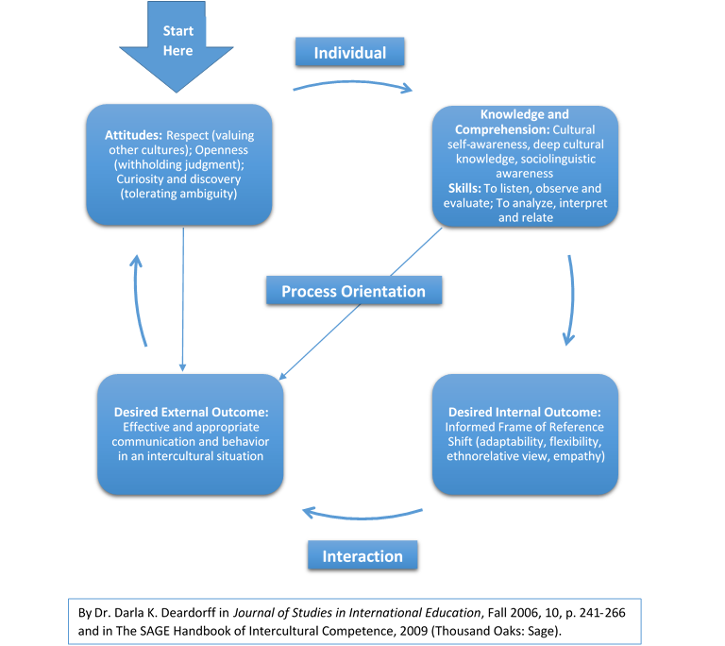

[Image description: Four blue boxes with white text and arrows between each box in the formation of a circle. On the Left an arrow points to box. The text in the arrow reads ‘start here’. The first box reads ‘Attitudes: Respect (valuing other cultures); Openness (withdrawing judgement); Curiosity and discovery (tolerating ambiguity’. The arrow circles to the right the word above the arrow reads ‘individual’. The box on the right reads ‘Knowledge and Comprehension; Cultural self-awareness, deep cultural knowledge and sociolinguistic awareness. Skills: To listen observe and evaluate, to analyse, interpret and relate. The next arrow circle to box underneath. The box reads ‘Desired Internal Outcome: Informed frame of reference shift (adaptability, flexibility ethno relative view, empathy)’ The next arrow follows round to left the text along the arrow reads ‘Interaction’ the final box reads ‘Desired external outcome: Effective and appropriate behaviour in an intercultural situation an arrow circle back to first box [ An arrow also runs directly down from the first box to this final box and another arrow runs directly with label ‘process orientation between the second and this final box. The model is credited to DR Darla K Deardorff p 241-266 in the SAGE Handbook of Intercultural Competence, 2009.]

Cultural Competence
The American National Association of Social Workers (2001) defines cultural competence as:
“the process by which individuals and systems respond respectfully and effectively to people of all cultures, languages, classes, races, ethnic backgrounds, religions and other diversity factors in a manner that recognises, affirms and values the worth of individuals, families and communities and protects and preserves the dignity of each.”
(NASW 2001: 11)

The terms Cultural Competence and / or Cultural Intelligence (CQ) are ones that newly qualified social work graduates will be familiar with – with the concept of intercultural competence it can be seen that like most all areas, terminology around this subject is evolving.

What Cultural Intelligence (CQ), Intercultural and Cultural Competence have in common
The traditional focus of CQ, intercultural and Cultural competence all usual mean culture as relating to ethnicity, background religious relating to the mix of cultures in different countries. To be fully inclusive in practice this resource covers intersectionality and allyship and in relation to competency relating to interacting with a diverse range of people, there are different cultures that relate to lived experiences other than pertaining to characteristics Race and Religion and Belief. – One example would be Deaf culture . It is important to have an understanding of different cultures, including disability or gay and intersecting culture/s be aware of language and models, practices that are most empowering from the lived experience perspective.
Expanding the example of Deaf Culture, it is important to understand the history and (oppressive) impact of Oralism on the Deaf Community and the different way being Deaf is perceived by Deaf people whose first language is British Sign Language. From the Deaf Community’s perspective, being Deaf is not considered a disability or a negative. (The hearing perspective that deafness is a negative). 2017 Ted Talk (16 minutes) Protecting and Interpreting Deaf Culture Glenna Cooper

Understanding Intersectionality
“The concept of intersectionality describes the ways in which systems of inequality based on gender, race, ethnicity, sexual orientation, gender identity, disability, class and other forms of discrimination “intersect” to create unique dynamics and effects.” Or
Intersectionality “is the interconnected nature of social categorizations such as race, class and gender as they apply in a given individual or group, regarded as creating overlapping and interdependent systems of discrimination or disadvantage….through an awareness of intersectionality, we can better acknowledge and ground the differences among us”
- Professor Kimberlé Crenshaw Defines Intersectionality
- 3 minute animation explaining intersectionality (and impact of, when not addressed in practice)
- 5 ways intersectionality affects diversity and inclusion at work.
- Why intersectionality matters for social work practice in adult services - Social work with adults (blog.gov.uk)
- Intersectionality: race, gender and other aspects of identity in social work with young people - Community Care
“Disabled people are also women, are from BAME communities and are from socio-economically disadvantaged backgrounds. This intersectional experience alongside its compounding disadvantages must be recognised and addressed.” Lockdown and Abandoned Report the experiences of Disabled people of Covid 19
“The disabled community is the largest minority group which anyone, through age, illness, accident or injury can become a part of at any time”
“1 in 4 Black British people are disabled” Ted Talk Triple Cripples – Empowerment as a Disabled Black Women 2020 Kym Oliver and Jumoke Abdullahi
“As many as 1 in 3 of the UK’s LGBTQ+ population are disabled ….” Ted Talk Anecdotes of a Disabled Gay by Wayne Herbert “it has taken so long for our community to recognise and harness the potential of someone like me and I can tell you why it’s because of the ever-present weight of low expectations that is present for everyone with disability and we need to change that.
Lesbian, gay, bisexual, trans, queer, questioning, intersex + (LGBTQI+) | SCIE – Resources for managers, commissioners, frontline practitioners, people who use services and carers about social care support for people who are lesbian, gay, bisexual, trans, queer, questioning, intersex or who hold identities such as non-binary.
In this interview Gay, disabled and Emmy-nominated: 'Special' creator Ryan O'Connell - YouTube(6 minutes duration) talks about how it was easier for him to be come out as gay (as he did at 17) then it was for him to be out about having cerebral palsy – he was 28 when he “came out the disability closet.” “I had not disclosed my cerebral palsy, I was just an accident victim in New York”. (The reason for his ‘late disclosure’ the impact of internalised ableism)
LGBTQ+ People of Colour reveal the challenges they’ve faced (video 7 minutes duration)
Ted Talk What more is there to say about LGBTQ+ issues by Suriya Aisha (7 minutes duration)

Deaf Culture and intersection
- ASL and Black ASL: Yes, There's a Difference (splinternews.com) (ASL = American Sign Language) about ‘code-switching’ in BASL and Deaf culture
- To Code Switch or Not to Code Switch? That is the Question. | Katelynn Duggins | TEDxMaysHighSchool – (a hearing community perspective)
- We need to talk about racism in the UK Deaf community - gal-dem
Intersectionality considers diversity intersection wider than just relating to the 9 protected characteristics in law, (demographic diversity) it also requires us to consider experiential diversity, (about the experiences that shape our emotional universe – family, friends backgrounds and cultures influencing our likes and dislikes and who we have an affinity with.) Cognitive diversity (Our unique way of understanding the world that prompts us to look for other minds that complement our thought – about our learning preferences are we introvert or extrovert and are we neurodiverse or neurotypical) and wider.

Allyship
“Allyship is the lifelong process in which people with privilege and power work to develop empathy towards another marginalized group's challenges or issues. The goal of allyship is to create a culture in which the marginalized group feels valued, supported, and heard. Being an ally is not a label -- it is a verb”
Kimberly Harden suggests “remember what ‘ally’ stands for
A: Admit you aren’t knowledgeable about certain things, and don’t know what to say or do.
L: Listen to different perspectives
L: Lean into discomfort and examine why you are uncomfortable
Y: Yield to the experience of the person being harmed instead of gaslighting the individual”
“[Racial] gaslighting is taking someone’s lived experience and telling them they’ve imagined it, or that they’re overemphasising something that, really, isn’t such a big deal. In doing this, we belittle their experiences, and re-cast them as unreliable narrators of their own lives. ….. White [non-disabled, heterosexual] folk have the privilege of never having to validate their experiences because their experiences are the default…. “Denial of a lived experience means marginalised groups are hurt twice; firstly in the initial incident, and secondly in having to push or fight to prove the validity of their ordeal. This takes up valuable time and energy, and can stop us from doing the more pressing work at hand.” Sophie Williams How Racial Gaslighting invalidates my experience as a black women.
- 3 ways to be a better ally in the workplace | Melinda Epler
- Be a Better Ally (hbr.org)

The Allyship journey applying a growth mindset
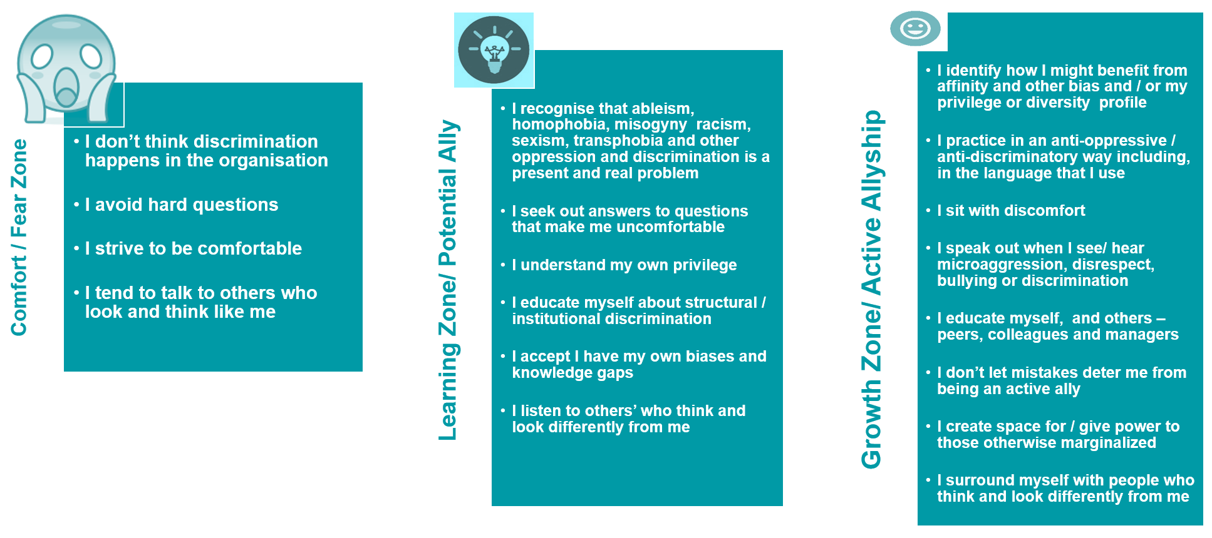Active Allyship Outcome: An intentionally inclusive and culturally intelligent ally and organisation
[Model Developed with inspiration from Dr Andrew Ibrahim’s Fear, Learning and Growth anti-racism model (developed for use in healthcare in the USA) but with transferable application Image description: The allyship journey- applying a growth mindset. There are three columns represented the one on left reads Comfort / fear zone with the statements: I don’t think discrimination happens in the organisation; I avoid hard questions; I strive to be comfortable; I tend to talk to others who look and / or think like me. The middle column reads Learning zone / potential ally with the statements: I recognise that ableism, homophobia, misogyny, racism, sexism, transphobia and oppression is a present and real problem; I seek out answers to questions that make me feel uncomfortable; I understand my own privilege; I educate myself about structural/ institutional discrimination; I accept I have my own biases and knowledge gaps; I listen to others who think and look differently to me. The column on the right reads Growth Zone Active Ally with the statements: I identify how I might benefit from affinity, intersectional and other bias and or my privilege / diversity profile; I practice in an anti-oppressive and anti-discriminatory way including in the language that I use; I sit with discomfort; I speak out when I hear microaggressions, disrespect, bullying or discrimination; I educate myself and others – peers, colleagues and managers; I don’t let mistakes deter me from being an ally; I create space for / give power those otherwise marginalised; I surround myself with people who think and look differently from me. – All columns are teal with white text.]

The goal is to become capable, not to get comfortable
Eight questions we can ask in the practise of our allyship to create space and promote inclusion, visibility and representation in our meetings (internal, for example team meetings and external):
- Who is in the room (meeting)?
- Who is trying to get into the room (meeting) but can’t? (From a physical access to and wider perspective) and whose presence in the meeting is under constant threat of removal?
- Has everyone been heard? [additionally, does the format of a meeting enable introverts to participate- and might Microsoft Teams support that creatively with for example comments enabled in team meetings]
- Whose ideas won’t be taken as seriously because they aren’t in the majority?
- What conditions have we created that mean certain groups are the perpetual majority here? [are we checking our affinity bias]
- How much more diverse is the representation of the group / meeting, this year compared to last?
- Is the environment safe for everyone to feel like they belong?
- Whose safety is being sacrificed and minimized to allow others to be comfortable maintaining views that might be perceived as disrespectful (for examples the implications of ‘banter’)
[Questions adapted and expanded upon from an article by Dr Stewart, Colorado State University]
- Psychological safety at Work (important in developing a culture of allyship)
- Let’s follow an Eightfold Path to psychologically healthy workplaces « Minding the Workplace

Understanding Privilege
“Privilege isn’t the presence of perks and benefits. It’s the absence of obstacles and barriers. That’s a lot harder to notice. If you have a hard time recognising your privileges, focus on what you don’t have to go through….”
- Upworthy the perfect explanation of privilege in a comic strip
- Nondisabled Privilege: What is it? | SFU OLC: Our Learning Community
- Why I Chose to Give Up My Disability ‘Passing Privilege’ | The Mighty
- Deconstructing White Privilege with Dr. Robin Di Angelo
- “I interrupted a Racist Joke Paul Scalon [Using privilege to call out racism – identifying the potential discomfort and cost in being an ally]
- My White Friend Asked Me on Facebook to Explain White Privilege. I Decided to Be Honest
- Race & Privilege: A Social Experiment | Regardless Of Race | CNA Insider - Bing video
- 30+ Examples of Heterosexual (Straight) Privileges 30+ Examples of Cisgender Privileges
- Paula Stone Williams: I've lived as a man and as a woman — here's what I've learned | TED Talk (her experience of impact of male privilege)
- These 25 Examples of Male Privilege from a Trans Guy's Perspective Really Prove the Point - Everyday Feminism
- 25 (More) Examples of Male Privilege as Experienced By a Trans Man - Everyday Feminism

Understanding unconscious bias
Unconscious biases are “simply our unintentional people preferences, created and maintained by the way our brains work, to sort data quickly and are influenced by our upbringing, media and our life experiences…. Studies have shown that unconscious bias can impact negatively on certain (often marginalised) groups.”
- Understanding unconscious bias | The Royal Society - YouTube
- How to tackle our biases head on
- Implicit bias test
- Can social work tackle unconscious bias?

2014 Research by Employer Network for Equality and Inclusion found that:
“Over one in three people show an unconscious bias against disabled people higher than levels of unconscious bias on the basis of race or gender”
And “Over a third of people (36%) tend to think of disabled people as not as productive as everyone else”
- Uncovering Disability Bias in the Modern Workplace
If a disabled candidate applied for a job in your area, which of the two infographics over page would most reflect how you think an interview panel might view them, would you need to check bias to give them equality of opportunity in shortlisting / at the interview?
- Disability and Leadership Report 2021 Birmingham University
- Disability and leadership: Engendering visibility, acceptance, and support | Insights | Heidrick & Struggles
- The importance of neurodiversity at work
- Disabled women challenges employers as a qualified teacher – 2 minutes duration
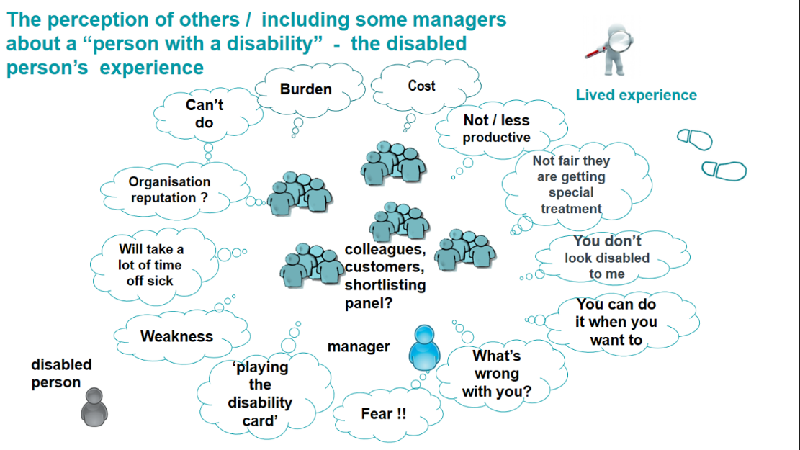
[Image / infographic description 1. The perception of others / including some managers about a “person with a disability” – the disabled person’s experience. There is an icon at the top right of a person with a magnifying glass looking at footsteps with the words lived experience next to them. In the centre of the image there are icons of group of people (representing colleagues and customers – 5 in total and an icon of a person representing manager. They are surrounded by a circle of thought bubbles and an icon representing a disabled person is on the outside of the circle. The thought in the bubbles (starting at the bottom left reading clock wise) read: “playing the disability card”; “weakness”; “Will take a lot of time off sick”; “Organisation reputation”; “can’t do”; “ burden”; “cost”; “not/ less productive”; “Not fair they are getting special treatment”; “You don’t look disabled to me”; “You can do it when you want to”; “What’s wrong with you?”; “Fear”
Note: Internalised ableism and unconscious bias could see a disabled person view themselves and other disabled people in this way – creating barriers to empowerment, inclusion and promotion. [These infographics were developed based on the experience of a number of disabled employees working in North Lincolnshire Council and also reflect the wider view and experience of other empowered disabled people.]
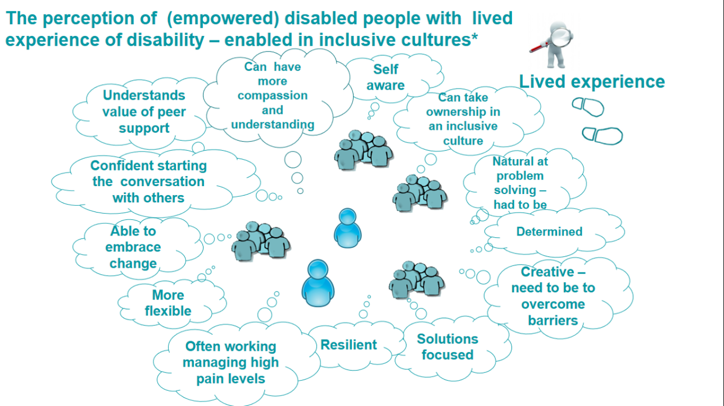
[a demonstration of how “disability can be an asset in a skilled leader.” Where are our disabled senior leaders? ]
[The second infographic on prvious page is titled The perception of the (empowered) disabled person with lived experience and enabled by inclusive cultures There is an icon at the top right of a person with a magnifying glass looking at footsteps with the words lived experience next to them. In the centre of the image there are icons of group of people (representing colleagues and customers – 5 in total and an icon of a person representing manager. They are surrounded by a circle of thought bubbles and this time an icon representing a disabled person is on the inside of the circle. The thought in the bubbles (starting at the bottom left reading clock wise) read: “more flexible”; “able to embrace change”; Confident starting conversations with others; “understands value of peer support”; “can have more compassion and understanding (empathy)”; “self-aware”; “Can take ownership in an inclusive culture”; “Natural at problem- solving – had to be”; “Determined”; “Creative- need to be to overcome barriers”; “solutions focused”; “Resilient”; “Often working managing high pain levels”

Micro behaviours

“Micro-behaviours are tiny, often unconscious gestures, facial expressions, postures, words and tone of voice which can influence how included (or not included) the people around us feel. The term ‘micro-behaviours’ was coined by psychologist Mary Rowe in the early 1970s. It relates to the concept of micro-inequities or micro-aggressions, which refers to the ways in which individuals may be singled out, overlooked or ignored based on an unchangeable characteristic such as race or gender. In a 10-minute conversation there might be 50 micro-messages transmitted between two people; psychologists call these positive and negative micro-behaviours.

Microaggressions / Micro-inequities
"a statement, action, or incident regarded as an instance of indirect, subtle, or unintentional discrimination against members of a marginalised group [can include for example, everyday slights, insults, negative verbal and non-verbal communication whether intentional or not]”
The motive for microaggressions / micro-inequities can be deliberate and intentional or unconscious and unintentional. – The impact for the person on the receiving end is the same,(this adds to the emotional labour accrued and carried on a daily basis.)
- What is a microaggression? And how do they impact people of colour?
- Better Working Culture – a focus on race and workplace culture and impact of microaggressions
- Disability Microaggressions AKA “Ableist things people say”
- How people’s misconceptions of disability leads to toxic microaggressions
- 14 Microaggressions LGBTQ People Deal With All The Time | HuffPost UK Relationships (huffingtonpost.co.uk)

Emotional labour
Is the act and impact of being ‘on guard’ to protect against bias relating to diversity or intersectional diversity and feeling different from peers / colleagues because of your identity [the inability to be yourself at work] and experiencing the associated effects on well-being and ability to thrive at work (and progress / seek promotion in your career).
Being “on guard” – consciously anticipating / preparing for potential bias or discrimination including bracing for an insult, downplaying an aspect of your identity, or avoiding interpersonal or workplace interaction out of fear of being stereotyped, mistreated, disrespected, gaslighted or receiving unfair treatment is the cornerstone of emotional tax.
In practice, emotional labour can involve suppressing your own emotions and feelings. "is the insidious wearying work of having to pretend you’re not as bothered by microaggressions in the workplace as you really are – whether these aggressions are racist, sexist, homophobic, transphobic, ableist or any situation where you feel like your identity has been attacked in some way and you have to pretend like it is fine.”
“We police our language and behaviour, we take on roles of healing when supporting each other and we carry the burden of educating in order to ‘teach’ or explain what microaggressions are” Sam Siva, writer and poet writing about the experience, emotional labour of black women
- Emotional labour: what is it, and why is everyone talking about it? - BBC Three
‘Passing’ / Covering / masking as a survival strategy (a person cannot thrive when all energy is investing in survival)
Goffman ...Identified what he termed ‘covering’ – “the strategy many of us take to conceal something about us that we feel ashamed of because of the stigma others attach to one or more aspects of our identity. Covering can be really exhausting and detrimental of the wellbeing, adding to the emotional labour of any one who uses such a strategy in an attempt to ‘fit in’.
Four types of covering used in the workplace Appearance: Covering up aspects of ones’ appearance, including attire and mannerisms.
1. Hidden or playing down impact of disability
2. Affiliation-based covering: Not talking about one’s identity or not wanting to support related work events or talks for fear of being outed.
3. Advocacy-based covering: Not wanted to be to advocate for, or sticking up for your group’s issues or colleagues. This results in down-playing their own condition. For instance, disabled colleagues, not championing, for instance disability rights events.
4. Association-based covering: For instance, not wanting to attend employee network groups for fear of being exposed and discriminated against. Adapted from In Uncovering Talent: A New Model for Inclusion, by Deloitte University [an American publication as reflected in use of some terminology]

Language Matters
“Language is not just a means of communication: it is a means of control” Ziauddin Sardar ‘the language of equality (PDF) The Language of Equality (researchgate.net) (2008)
In exploring language, it is important to check our bias for ‘political correctness’ or perceive ‘woke’ or ‘cancel culture’ – to understand that words carry power. Below, are three tips promoting anti-oppressive practice:
- It is good practice when working with people – individuals or groups to ask, how they describe themselves (avoid gaslighting people telling them they shouldn’t for example call themselves a disabled person but instead say they are a person with a disability. How the person identifies or wishes to be addressed should be respected – this includes for example the elderly man who prefers to be known as Mr Smith rather than the informality of by their first name or for the woman that never married, it matters to use Miss rather than assume Mrs, the colleague whose name is Victoria and likes to be known as Victoria, doesn’t like it to be shortened to ‘Vicky’ – it is the respectful thing to call them Victoria – check before shortening or using a different name.)
- Not every individual will identify or understand the (small p) ‘political’, equality driven or other context to the language they use to describe themselves
- It is good to ask, where does the language come from, is the individual / group working from a place of empowerment, oppression or honest ignorance? – This is often identified by the language used. – Language used can also be a clue as to how people have become used to being treated and how they behave and present. [Not all gay men or women will associate with the fuller LGBTQIA+ term used to describe a very diverse community, and some of that could be influenced by their own conscious and unconscious biases and perceived conflict of needs.]

Very often, the language used to describe diverse groups of people / communities whose lived experiences are different from the majority group (people who share the privilege and / or do benefit from a majority (affinity) bias as a white, non-disabled, heterosexual cis person), is defined, by people in those majority groups and the language doesn’t always reflect the person with a particular minority lived experience’s view experience – can feel oppressive and (unconsciously) reinforce negative stereotyping and barriers to their opportunities and inclusion.

Specific example – ‘special needs’
Consciously or unconsciously, language does have impact for the way people are viewed and treated, with a power to have negative impact for their life chances. For example, if a person is described as ‘Special needs’ or ‘having special needs’. It is the lived experience of Disabled people that they will have a less equal chance to life opportunities – educational, employment and social. The negative stereotyping and bias associated with the term ‘special’ will see disabled children and adults as less able and therefore not equal to non-disabled children and adults. ‘Special needs’ is the language of the non-disabled majority (including some non-disabled parents of disabled children) to describe a specific need that is different from the majority. From an (empowered) Disabled person perspective, for more than twenty-five years equality legislation has required that schools, employers and service providers make reasonable adjustments to meet specific needs of disabled people. So it is a right – there is nothing special about that. In addition, when a term becomes used in a derogatory, mocking or abusive ways “He’s a bit special” it becomes a term disabled people don’t want to be associated with. (Although it should be noted that sometimes groups ‘reclaim’ oppressive language for example the term ‘queer’ reclaimed by some members of the LGBT+ community – some other members will find offense in the term)
Terms commonly used by services who work with disabled people like ‘vulnerable’ become problematic for the disabled employee, potential manager and leader – if disabled ‘service users’ (might be described as service users with disabilities by the non-disabled professional) are seen as ‘vulnerable’ how does that impact for the disabled employee – can their leadership potential be seen and nurtured or does the impact of unconscious bias create barriers to promotion?
- Not Special Needs – a 2 minute video by People with Downs Syndrome
- Why disability activists argue against labels like ‘differently abled’
- We are so much more (than the term ‘vulnerable’ - Community Catalysts
The use of language / changing language is often links to rights and the fight for rights particular groups (and their allies) have and continue to have. For example, out of the Disability Rights Movement (Disabled people, their organisations and allies) came the social model of disability and preferred terminology of Disabled person. A solutions / inclusion focused approach – using the social model of disability, the person is disabled by the barriers and not their impairment/s or health conditions, with legislation and a duty to make reasonable adjustments, disability becomes a shared responsibility and the fight for rights resulted in the Disability Discrimination Act 1995 (superseded by the Equality Act 2010.)
The Powerful New BBC Drama ‘Then Barbara Met Alan’ Is Shifting The Needle On Disability Rights | British Vogue (2022)
Similarly language relating to lesbian, gay, bisexual, transgender, queer, intersex and ace identifying people has been driven by LGBTQ+ people and their organisations and activists amongst that very diverse community / communities of people. #PrideJubilee TV film | Pride in London 2019 - YouTube
Interesting to note that one of the two people most associated with the Stonewall Riots in 1969 (the first Pride took place on the anniversary of that protest) was a Black Disabled trans woman Marsha P Johnson along with a Latina trans woman Sylvia Rivera (intersection is not a new thing). It is also interesting to note that the terminology transgender didn’t exist until 1971 and the term ‘trans’ only used from about 1996 – language evolves but transgender people including non-binary transgender people have always existed it is just as the Stonewall uprising and Pride movement empowered LGBTQIA+ people so the language developed to describe their identity and experiences in a reclaimed and or empowering way.
Relating to Race, terminology has evolved over the years, the exploration of terminology hit the headlines in 2021 with the publication of the findings of Sewell Report The report of the Commission on Race and Ethnic Disparities - GOV.UK (www.gov.uk)
Working in a culturally intelligent way, it is important to understand that language can and is used differently in different countries for example African America and People of Colour and Black people are all terms that can be identified as terminology used in America and the different use of language in America to describe identity is related to American culture and Black History. This can also be seen in European context, where the term people with disabilities is used as it is sometimes in America. Where an organisation is lived experience led, the term Disabled person is used and the shift in that terminology can be seen – asserted by empowered Disabled including neurodivergent and Autistic people. (like with Black person, Disabled people often use a capital letter to denote a small ‘p’ political statement, the Disabled person is mostly disabled by the barriers and not by their impairments – many of the barriers can be removed or mitigated with reasonable adjustment / inclusive and anti-oppressive organisational practices and values.)

Relating to Disability - Anti-ableist language
“Language is ever-changing, so eliminating ableism from your vocabulary will be an ongoing process rather than a static victory. You may stumble, but checking in with [empowered] Disabled people is an effective way to … continuing to build a more inclusive vocabulary…. Think about whether your own word choice is contributing to their oppression.” BBC Equality Matters Article ‘The harmful ableist language you unknowingly use’ by Sarah Novic 2021
- 1 in 15 a video about how disabled people want to be represented / seen (2021)
- Ted Talk: I’m not you’re inspiration, thank you very much by (the late) Stella Young 2014 - 9 minutes duration
Currently relating to disability, the neurodivergent community (– neurodiversity) autistic and neurodivergent people are determining the language they prefer and find empowering for example, the Autistic person who identifies as Autistic (and disabled) rather than person with autism . The terms ‘on the spectrum’ ‘high functioning’ and Asperger’s are terms that may cause offence and are to be avoided. It should be noted that neurodiversity is part of our collective cognitive diversity
“The neurodiversity movement makes it clear that individual neurodivergence does not equate to a neurological disorder. That word, disorder, fundamentally implies that something is wrong with a neurodivergent person.”
Why I DON'T use the term Asperger's (explores a whole range of context – including the diagnostic journey, masking and authentic identity)
- The Language of Neurodiversity: Terms and Definitions in the age of… | by Susan A. Fitzell | The Learning Strategist IQ | Medium
NEURODIVERSITY: SOME BASIC TERMS & DEFINITIONS • NEUROQUEER
The language of neurodiversity? - The Donaldson Trust (donaldsons.org.uk)
A gender bias can exist around diagnosis
It all made sense when we found out we were autistic - BBC News (Women’s experiences)
Common Signs of Autism in Women | The Mighty

Relating to Race – Anti-racist language
The challenge of terminology BAME (should not be used to describe an individual)
Why we no longer use the term ‘BAME’ in government - Government Equalities Office (blog.gov.uk)
With the Sewell report last year, the discussion on language around race made headlines the three tips identified on pp.13-14 identifies the importance of asking, to provide a context black, Asian and minority ethnic staff networks who are part of the Humber Coast black, Asian and minority ethnic network of networks after discussion identified that they would continue using the terminology black, Asian and minority ethnic to describe their staff networks - important to note that it is not abbreviated to BAME.
The term Black, Asian and minority ethnic like the shortened term LGBTQIA+ is a term used to capture a diverse group of diverse communities who have in common the experiences, barriers and discrimination they have experienced because of a particular characteristic. For example in the case of Black, Asian and minority ethnic people an experience or emotional labour or microaggression associated with racism.
“We police our language and behaviour, we take on roles of healing when supporting each other and we carry the burden of educating in order to ‘teach’ or explain what microaggressions are” Sam Siva, writer and poet writing about the experience, emotional labour of black women
The term Black, Asian and minority ethnic shouldn’t be used to describe an individual – rather on meeting a person / family and engaging with them it will become clear how they prefer to identify or, perhaps working with a colleague who identifies as a Black women, that descriptor in relevant circumstances will be important because of the different lived experiences, emotional labour and opportunities your Black female colleague will have compared to a white (non-disabled) women including the absence of the privilege of affinity bias.
To provide a bit of historical context in the UK, the term Black has been used routinely in anti- racist campaigns starting in the 70s. “Black is used to indicate people with a shared history. Black with a capital ‘B’ is used in its broad political and inclusive sense to describe people in Britain that have suffered colonialism and enslavement in the past and continue to experience racism and diminished opportunities in today’s society…… Language changes and evolves but terminology is always important in terms of intention and direction” [Unison Website]
The BAME debate: Why terminology matters when we're talking about race | Metro News
Racial Categorisation and Terminology | Black British Academics
A guide to race and ethnicity terminology and language | The Law Society

Relating to Sexual orientation / sexuality
Language relating to sexuality that relates to sexualities that sit within the Asexual / Ace umbrella and an understanding of what asexuality means is provided in the section Sexual Orientation (including people who might identify as ACE) and, anti-homophobic, anti-biphobic and other related anti-discriminatory approaches (pp 30-34)

Relating to gender identity
These two Ted Talks are helpful for understanding language and gender identity
How to talk and listen to transgender people Jackson Bird 2017 (six minutes duration) Jack identifies in their talk:
“…As soon as [someone] tells you their new name and pronouns, that's when you start using them. It can be difficult to make the change. You might slip up here and there; I've slipped up myself with other trans people. But I always think to myself, if we can change from calling Puff Daddy to P. Diddy, and if we apologize profusely when we've used the wrong gender pronoun for someone's pet cat -- I mean, I think we can make the same effort for the real humans in our lives...”
Language around gender and identity evolves (and always has) Archie Crowley 2021 (fourteen minutes duration.) Archie identifies in their talk:
“..Language is a powerful tool for explaining and claiming our own identities and for building relationships that affirm and support us. But language is just that, a tool. Language works for us, not the other way around. All of us, transgender and cisgender can use language to understand ourselves and to respect those around us…”

Part two Characteristic specific understanding promoting anti-oppressive, culturally intelligent and inclusive practice and leadership – includes ways to be an active ally

Disability and anti-ableist approaches in practice
Being anti-ableist is an active (and anti-oppressive) practice. It involves working against ableism, racism and all forms of discrimination / oppression
To support understanding of how ableism and related (intersectional diversity) discrimination can manifest (so we can be anti-ableist in our allyship,) definitions and information about ableism and impact are provide below.
Ableism as a term and concept is relatively new (sometimes the term disablism has been / is used) definitions vary and are evolving for example, a most recent and working definition (2021) from American TL Lewis (and acknowledging the intersection and shared issues relating to justice and discrimination) and perhaps challenging definition, identifies ableism is
“A system that places value on people’s bodies and minds based on societally constructed ideas of normality, intelligence, excellence, desirability and productivity….. This form of systemic oppression leads people and society determining who is valuable and worthy based on a person’s [spoken] language, appearance religion and or their ability to satisfactorily [re] produce, excel and ‘behave’ you do not have to be disabled to experience ableism”
Ableism definition two: A set of beliefs or practice that devalue and discriminate against the diverse range of disabled people. Often perpetuating a view that disabled people need to be ‘fixed’ or want or need a ‘cure’ [– see medical model of disability] and that the lives (and quality of lives) of disabled people are not equal to non-disabled people’s lives”
- British Institute of Human Rights Report ‘Scared, Angry, Discriminatory, Out of my control DNAR (Do Not Attempt Resuscitation Orders) decision making [in pandemic] in 2020’
Ableism definition three: Discrimination and bias (conscious and unconscious) in favour of non-disabled people / that discriminates against disabled people .
- Ableism 101: What it is, what it looks like and what we can do to fix it
- You're probably being ableist and don't even know it | Metro News (2021)

Social Work / Social Care specific articles relating to ableism
Unlearning ableism a social worker’s duty article October 2021
Chronic Illness Inclusion Ableism in Health and Social Care

Challenging ‘ableism’ and teaching about disability in a social work classroom: A training module for generalist social workers working with people disabled by the social environment

Homecare UK A definition of Ableism and how to challenge it
Uncovering issues of ableism in social work education: a disability needs assessment Taylor and Francis online
Dismantling ableism in social work (the perspective of a disabled social work student)
Unlearning ableism a social workers duty article August 2021
Ways to advocate against ableism as Christian Social Worker (a relevant read for any social worker)

NHS specific articles relating to disability ableism
Ableism and the NHS: Tackling premature deaths of people with learning difficulties : Centre for Health, Technologies and Social Practice (leeds.ac.uk) (2013)
What Is Ableism and how does it affect those with invisible disabilities? | DPT
Women’s Healthcare Survey reveals 'medical ableism' - Chronic Illness Inclusion (2021)
How to recruit and support disabled staff in the NHS | NHS Employers

Other useful links to support ally understanding
A guide to disabled people, for non-disabled people - DPAC
Forbes (March 2022) The many flavours of disability bullying [ableist harassment including an explanation of ableist gaslighting]
Ted Talk I have one more chromosome than you. So what? Karen Gaffney a person with Downs Syndrome talking about issues of inclusion
Ted Talk Purposeful Steps away from ableism Alyson Seale (a non-disabled ally) 2019 – 18 minutes duration
How do you figure out who you are when you’re the only disabled person in your family

More examples of the ways in which ableism can manifest / be perpetuated:

Internalised ableism
Is “the phenomenon of disabled people (including neurodivergent people) believing prejudices about themselves that become internalized by daily living in an ableist society”
"Internalized oppression is not the cause of our mistreatment, it is the result of our mistreatment. It would not exist without the real external oppression that forms the social climate in which we exist. Once oppression has been internalized, little force is needed to keep us submissive. We harbour inside ourselves the pain and the memories, the fears and the confusions, the negative self-images and the low expectations, turning them into weapons with which to re-injure ourselves, every day of our lives" Michele Mason 1990
Note that internalised ableism can be perpetuated by the services a disabled person accesses including health and social care.
An example of how ableism can become internalised -The impact of normal and different understanding of independence.
A prevailing view sometimes enforced by ‘rehabilitation services’ is that for a disabled person to be independent, they need to be able to do for themselves. To give a simple example, a lot of time and energy can be wasted for the disabled person who has difficulty cutting up vegetables. Professionals may spend time to get them practising this task regardless of the impact that might be having for the individual (including frustration and internalised feeling of failure.) Independence for the empowered disabled person looks very different. Independence being about the choice the disabled person has about the assistance you require to do those things that you cannot do for yourself / need assistance with. Solutions focused, that could include employing a personal assistance to support with the preparation of a meal or even buying pre-cut / oven ready vegetables to use / time and energy in a more useful way.
Note that when a non-disabled person use their income to hire a cleaner to help with household chores, perhaps a nanny to help with child care, their independence is never questioned. That is an example of non-disabled middle class privilege.
- Internalised Ableism the struggle to accept our own worthiness
- What is internalised ableism and what can we do to overcome it
- Coping with internalised ableism and self-loathing
- Implications of internalised ableism for the health and wellbeing of disabled young people
- Grappling with Ableism in the Para-sport Movement (the impact of internalised ableism / how ableism is perpetuated by disabled people)

Manifestation of disability – related (ableist) harassment
- Manifestation of disability related harassment
- Harassment can look like a person, name calling, bullying or directing ‘banter’ at a person because they identify as a disabled person or alternatively, use of ableist slurs including for example “he’s a bit special.”

In an employment context
- Harassment relating to “faking it” can manifest in the workplace. Example A manager having a view that they have seen a person walk upstairs before, so they (the manager make a judgement a reasonable adjustment of a ground floor room for the team meeting isn’t necessary (making it difficult for the disabled employee to request that when they need it, and to challenge it (or ask for any other workplace adjustment) the perception might be they are ‘playing the disability card.’) [ Can also happen in an assessment of disabled customer, if bias isn’t checked]
- it can also include pressure on a person to ‘able pass’ (in order to ‘fit in’)
- an anticipation that a disabled employee has a bias in favour of disabled people, will automatically take the side of another disabled person because there is a shared characteristic or be unable to offer a ‘professional’ judgement on the reasonableness of a decision on access issues for example) because they are a disabled person themselves (when done in an ‘intimidating’ way or a way that a person is made to feel degraded or their view marginalised, it could constitute harassment as defined in the Equality Act 2010)

Six ways to be an ally to Disabled people
- Challenge the representation of Disabled people including neurodivergent people, in engagement and by non-disabled people – are disabled people represented where decisions are made about services that affect them (‘Nothing about us without us’)
- Apply the social model of disability / Cultural model of Deafness – focus on removing the barriers a person is experiencing (the disability they experience) rather than being ‘inappropriately curious’ about ‘what is wrong with them’ (their impairment or condition.)
Note the Equality Framework for Local Government | Local Government Association identifies ‘the organisation has adopted the social model of disability’ as a criteria of excellence
- If you are non-disabled use your privilege to create space, anticipate and remove the barriers for disabled colleagues and enable colleagues who may be ‘able-passing’ to feel safe (not to have to ‘cover’) – What is psychological safety at work [The lived experience of disabled people / one impact of ableism is that they might fear being accused of ‘faking it’ especially if “you can’t tell”)
- Use anti-oppressive language and avoid asking “ What wrong with you? Or being inappropriately curious about a person’s health conditions and call out ‘inspirational’ and other disability related stereotyping
Ted Talk: I’m not you’re inspiration, thank you very much by (the late) Stella Young 2014 - 9 minutes duration
- Understand the ways a disabled person might differently manage tasks to take account of their different ‘energy allowance’ for example use of reference to spoons and ‘spoons theory’
- Understand that because of unconscious bias, social conditioning and different lived experience (see covering and internalised ableism) a disabled person could just as easily perpetuate ableism as a non-disable person might. A useful question to ask is, am I more likely to listen to the disabled person who may be covering but is agreeing with me or the disabled person who is asking an uncomfortable/ challenging question?
Ten Ways To Be A Good Ally To Disabled People
To support allyship of neurodivergent and Autistic people (see also Language Matters p.17 )
- Home | Autistic Social Worker
- Neurodiversity in the Corporate World: Untapped Talent, Employee Retention and Success - YouTube
- Neurodiversity at work | CIPD
Be aware that late diagnosis is common for men, women and non-binary people and gender bias can exist around diagnosis
- It all made sense when we found out we were autistic - BBC News (Women’s experiences)

Other useful resources
Disability News Service – Lived experience led reporting DNS “launched in April 2009 to address the absence of in-depth reporting in both the specialist and mainstream media on issues that affect the lives of disabled people. The news service focuses on issues such as discrimination equality, independent living, benefits, poverty, activism and campaigning and human rights, but also covers employment, transport, education, housing, crime, and arts, culture and sport”
- Example Disability News Service reporting relating to social care Example Disability News Service reporting relating to NHS / Health

Race and anti- racist approaches and practice

Understanding Race – 3 definitions
- Race “is an arbitrarily organised combination of physical traits, geographic ancestry, language, religion or variety of other cultural features”
- “A social construct that assigns people to different groups based on physical, national or linguistic characteristics. Racial categories are based upon social rules that vary between countries although they can have very substantial impacts, positive or negative, on the lives of individuals who are seen as being part of a particular group.” - A person’s own identity may or may not include aspects of race attributed to them by others
- From an Equality Act definition understanding “Race can mean your colour, or your nationality (including your citizenship). It can also mean your ethnic or national origins, which may not be the same as your current nationality. For example, you may have Chinese national origins and be living in Britain with a British passport.
Race also covers ethnic and racial groups. This means a group of people who all share the same protected characteristic of ethnicity or race. A racial group can be made up of two or more distinct racial groups, for example Black Britons, British Asians, British Sikhs, British Jews, Romany Gypsies and Irish Travellers.
You may be discriminated against because of one or more aspects of your race, for example people born in Britain to Jewish parents could be discriminated against because they are British citizens, and/or because of their Jewish heritage – either is unlawful.” Queen Mary University of London explanation
Anti-racism is more than ‘not being’ (racist) it means, taking proactive and deliberate action to root out racism within communities, organisations and yourself . Whilst also, being an advocate for equity, inclusion and justice
“Anti-racism can be an individual’s approach to countering racists behaviours and impact, but individual actions can have a broader effect as well, particularly when leaders commit to organisation-wide steps with consistent follow-up” From Employers Network on Equality and Inclusion Webinar on Anti-racism

Types of Racism
Individual racism “Beliefs, attitudes and actions of individuals that support or perpetuate racism conscious and unconscious ways”
Interpersonal racism “Occurs between individuals. These public expressions of racism, often involve slurs biases or hateful words and actions”
Institutionalised Racism “The collective failure of an organisation to provide an appropriate and professional service to people because of their colour, culture or ethnic origin. It can be seen or detected in processes, attitudes and behaviours which amount to discrimination through unwitting prejudice, ignorance, thoughtlessness and racial stereotyping” The Macpherson Inquiry into the death of Stephen Lawrence (which led to the first Public Sector Equality Duty – the (proactive) Race Equality Duty which was integral to the Race Relations Amendment Act 2002 (and superseded by the Equality Act 2010)
Stephen Lawrence Day Foundation: A Legacy For Change
Structural / Systemic Racism overaching systems of racial bias across institutions and society. These systems give privileges to White, heterosexual, non-disabled people.

The danger of a single story
“The single story creates stereotypes and the problem with stereotypes is not that they are untrue but that they are incomplete …. Stories matter, many stories matter, stories have been used to dispossess and to malign but stories can also be used to empower and to humanize” The Danger of a Single Story Ted Talk Chimamanda Ngozi Adichie
“The consequence of a single story is that it robs people of dignity, it makes our recognition of our equal humanity difficult. It emphasizes how we are different rather than how we are similar” The Danger of a Single Story Ted Talk PDF Summary - Chimamanda N. A. (12min.com)

Six ways to be an ally to Black, Asian and (other including white) minority ethnic people
- Challenge the representation of diverse Black, Asian and minority ethnic people, in engagement how are they represented where decisions are made about services that affect them
Lightbulbs, leadership and being true to yourself - Social work with adults (blog.gov.uk)
White people in black spaces
- If you are white (British) use your privilege to create space in work meeting and EPRM, supervision and assessments to anticipate and remove the barriers for Black, Asian and minority ethnic colleagues and enable colleagues who may –‘passing’ as part of the white majority to feel safe (not to have to ‘cover’) – What is psychological safety at work [Refer back to ‘covering’ on page 15 of this resource
Black, ethnic minority and disabled practitioners face ‘disproportionate’ difficulties passing ASYE, says BASW - Community Care
Working While Black: 10 Racial Microaggressions Experienced in the Workplace (crunkfeministcollective.com)
- Use anti-oppressive language - take the lead from your colleague or customer, if their name is one you haven’t heard before, listen to how they pronounce it, the language they use to describe themselves e.g. black women, women of colour, Somali women, Black British women. – check bias – the question “Where are you from?” can identify bias, a Black person will be asked this more than a white employee (with the bias expectation of a person not being British – it is the tone, nuance and the way that question is asked that will identify that for the person being asked.)
- Educate yourself to reduce the emotional labour on Black, Asian and minority ethnic colleagues and managers – avoid always giving them the cases involving Black or brown families. Any member of the team should with CQ be able to meet the needs of all customers they are working with. Also be aware of the impact of what is going on nationally and internationally, for example, the impact of the death of George Floyd and black lives matter movement, compounded because it happened in a pandemic where there has been disproportionate impact for Black and Asian women /people at further additional impact of racism in English football with the World Cup
Lessons from Southgate: what the England manager can teach us about leadership | by Keele University | Keele University

Black people face racism at work constantly. Don't make them solve it | Fortune
What's wrong with saying "I Don't See Colour"? — Erfan Daliri
- Understand that because of unconscious bias, social conditioning and different lived experience (see covering and internalised racism) a Black, Asian or other minority ethnic person might not feel safe to openly ally other colleagues with a similar lived experience
- Challenge or take action on racism, a comment or slur regardless of whether a Black, Asian or minority ethnic person is in the room or not “I interrupted a Racist Joke Paul Scalon [Using privilege to call out racism – identifying the potential discomfort and cost in being an ally]

- How can people be good allies to Black, Asian and Minority ethnic colleagues
- Deserved shame and the white anti-racist – South of Therapy

Social Work / Social Care specific articles relating to race and racism
Let's talk about race and racism as social workers | Frontline (thefrontline.org.uk) (2020)
Anti-racism in Social Work 2021 (local.gov.uk)
How to promote an anti-racist culture in social work - Community Care
Black social workers: Identity, racism, invisibility/hypervisibility at work - Chijioke Obasi, 2022 (sagepub.com) 2021

NHS specific articles relating to race and racism
- NHS organisational workplace inequalities | The BMJ
- Fighting against micro-aggressions for minority ethnic nurses - Social care (blog.gov.uk)
- Racism an issue in NHS, finds survey (bma.org.uk) (2022)

Other useful organisations / resources relating to race and anti-racist approaches
- Race Equality Foundation – Promoting equality in health, housing and social care
- Black History Month 2022: News Views and Opinion
- Black, Asian and minority ethnic disabled people – articles from Disability News Service
- Social Workers Without Borders
- Culture, spirituality and religion: migrant health guide - GOV.UK (www.gov.uk)

Podcasts
The Social Matters Podcast: Episode 17 (S3). A year since George Floyd's murder. on Apple Podcasts
Please see the web links below for the above podcast interview with Andy McClenaghan, Narinder Sidhu & I.
Black Lives Matters — The Social Work response to challenging racial injustice:
- https://podcasts.apple.com/gb/podcast/black-lives-matters-social-work-response-to-challenging/id1511140451?i=1000484050913
- https://soundcloud.com/user-750691560-622997630/black-lives-matters-the-social-work-response-to-challenging-racial-injustice-in-the-uk
- http://socialworldpodcast.com/
- https://open.spotify.com/episode/7lM0JsrRTZEHdfvdPIvX2P?si=xQstXMuwQPKV1m
Anti-racism in Social Work portfolio for Wayne Reid.pdf (local.gov.uk)

Research in Practice resources - you may need a RIP licence to access some of these
Research in Practice – latest children & families learning – choose equality and diversity for all resources
An introduction to cultural competence in social care (researchinpractice.org.uk)
Racism, intersectionality, privilege, power, fragility and allyship (researchinpractice.org.uk)
Black, Asian and minority ethnic leadership matters: Children’s Webinar (2021)
- Confident practice with cultural diversity: Children’s Frontline Briefing (2017)
- Embedding trauma-informed approaches in adult social care: Adults Frontline Briefing (2019)
- Wellbeing supervision: Adults Supervisors Briefing (2019)
- Reflective supervision: Children’s Resource Pack (2017)
- Supervision Change Project: Adults (2018)
- Promoting anti-racism in social work (researchinpractice.org.uk)
Useful Websites
- Hair and skin are important to a black child's identity – but many social workers don't understand this (theconversation.com)
This toolkit has been put together by Children Social Work Matters bringing useful information and guidance together.
- Learning & Knowledge Centre | Our Children's Social Work Matters (childrenssocialworkmatters.org)
Useful resources collated and available on the BASW website.
- Black, Asian and minority ethnic community resources | www.basw.co.uk
BASW YouTube channel. This channel has videos that explore various social work policy, practice and education matters.
- BASW_UK - YouTube

A toolkit ‘The BAMEed Network’ provides access to a variety of useful resources and reading to educate society including articles, audio, books, data, research and videos
- Resources database – BAMEed Network
- TACT's Black Lives Matter Action Plan | TACT Fostering (tactcare.org.uk)
- Black Children's Lives Matter - Nagalro
- RACISM, RACIAL DISCRIMINATION – EDUCATION & ACTIVISM (niromp.org)
- Tackling racism in the workplace | CIPD

Supervisor Development Programme – all HSWTP can access this
- Supervisor Development Programme Tools (2019)

Practice Supervisor Development Resources
- Building a Trauma-Attuned and Socially Just Organisational System
- Developing cultural competence (2019)
- Critical conversations in social work supervision (2021)
- Exploring diversity in supervision: Practice Tool (2019)
- Social GGRRAAACCEEESSS and the LUUUTT model (2019)
Dr. Robin DiAngelo discusses 'White Fragility' https://www.youtube.com/watch?v=45ey4jgoxeU&t=1s
Serious Case Review (SCR) 2018 commissioned by Newham Safeguarding Children Board (NSCB) following death of Chris, a fourteen-year-old boy of Caribbean heritage
Serious Case Review (SCR) 2011 Gloucestershire Safeguarding Children Board following fatal injuries to ‘Rachel’ under 2 years old, family recently migrated to UK.
overview_report_0310-50050.pdf (gscb.org.uk)

Booklist
This book is an empowering resource for Foster carers and Adopters of Black and Mixed heritage children. Also, a learning and development tool for Social Workers and other professionals.
Black Children in Care: Health, Hair and Skin: Amazon.co.uk: Lewis, Denise, Awolaja, Flora: 9780957647107: Books
- https://siobhanmaclean.co.uk/publications/outlanders
- https://www.waterstones.com/book/raceless/georgina-lawton/9780751579383
- https://siobhanmaclean.co.uk/publications/developing-cultural-competence-in-social-and-health-care
- https://www.amazon.co.uk/Cultural-Diversity-Child-Protection-Competence/dp/1352006200
- https://vottraining.co.uk/order-book/ols/products/diversity-acrostic-poem-book1

Community Care articles
Black Lives Matter: social work must respond with action - not platitudes - Community Care
If social work knowledge is still based on western values, can practice really be anti-oppressive? (communitycare.co.uk)

Guides for parents - Other resource
- A Parent's Guide to Black Lives Matter (yoopies.co.uk)
- White privilege - a guide for parents | Barnardo's (barnardos.org.uk)

Sexual Orientation (including people who might identify as ACE) and, anti-homophobic, anti-biphobic and other related anti-discriminatory approaches
Allyship around sexual orientation involves promoting anti-homophobic, anti- biphobic and anti-discriminatory (to broader sexual orientation / sexuality e.g. ace) practice.
Being anti-homophobic and anti-bi-phobic is an active (and anti-oppressive) practice involving a conscious effort to work against homophobia, bi-phobia and other sexual orientation related discrimination. It is a practice promoting sexual orientation equality, dignity and respect for all.
To support understanding of how homophobia, biphobia and other sexual orientation related discrimination can manifest (so we can be anti-homophobic, anti-biphobic and anti-discriminatory in our allyship,) definitions and information about biphobia and homophobia are provide below.
Biphobia The fear or dislike of someone who identifies as bi based on prejudice or negative attitudes, beliefs or views about bi / bisexual people.
Note Bi is an umbrella term used to describe a romantic and /or sexual orientation towards more than one gender.​
Homophobia The fear or dislike of someone, based on prejudice or negative attitudes, beliefs or views about lesbian, gay or bi people.

Example of the ways in which homophobia can manifest:
Believing that it is just a phase or that a lesbian or gay or bi person hasn’t made their mind up yet
Denying the identity a person has identifying as a lesbian, gay or bi person
Harassing a person, name calling, bullying or ‘banter’ directed at them because they identify as lesbian, gay or bi.
Harassing a person, name calling, bullying or ‘banter’ directed at a person because they are perceived to be lesbian, gay or bi.
Microaggressions targeted at a person because they are or are perceived to be bi or talking about a person being lesbian, gay or a bi in a derogatory way.
Internally – Internalised homophobia Internalised Homophobia - Rainbow Project (rainbow-project.org)

Additional example of the ways in which bi-phobia can manifest:
Assuming a person is gay, lesbian or heterosexual based on their current relationship
Note also the term Bi erasure is used to describe when existence or legitimacy of being bisexual (either in general or in regard to an individual) is questioned or denied outright.
The BisexualityReport Feb.2012_0.pdf (open.ac.uk)
Further, this article will help with understanding the microaggressions LGBTQIA+ people experience 14 example of microaggressions LGBTQIA+ people deal with all the time

Asexuality / ace
It is estimated 1% of the population are asexual (Source David Jay)
Approximately 50% of that 1% who are asexual will identify as romantic and the other half aromantic
Asexuality: is the lack of sexual attraction to others or low or absent interest in or desire for sexual activity, it may be considered a sexual orientation or lack thereof. It may also be categorised more widely to include a broad spectrum of asexual sub- identities e.g. demi sexual.
Ace is an abbreviated form of asexual to describe people who identify as being on the ace spectrum – this includes, asexual people, demi-sexual people and gray-sexual people.
Being asexual is about having no sexual attraction to other people or low or absent interest in or desire for sexual activity, it is not the same as abstinence or celibacy which are choices or a requirement (in the case of some religious beliefs for example) to refrain from sexual activity. Some people in the asexual / ace spectrum will participate in sexual activity, it is just they experience ‘attraction’ to other people differently.
More information is available from The Asexual Visibility and Education Network AVEN

Six ways to be an Ace Ally
If someone comes out to you as ace, believe them and be respectful (it is not your place to tell their story.)
Read up about ace sexualities – more information is available from the AVEN website (link above
Don’t assume everyone needs sex or romance in their lives to be happy.
Remember an ace person may have an additional identity (relating to sexual orientation). An asexual person who is romantically attracted to men, women and non-binary people may identify themselves as pan or a person who identifies as attracted to people of the same gender or sex may identify as gay.
Don’t ask intrusive questions
Call out ace-erasure or discrimination where you see it.

Useful resources
Challenging Heterosexism: 6 Suggestions for Social Work Practice - SocialWorker.com
Lesbian, gay, bisexual, trans, queer, questioning, intersex + (LGBTQI+) | SCIE – Resources for managers, commissioners, frontline practitioners, people who use services and carers about social care support for people who are lesbian, gay, bisexual, trans, queer, questioning, intersex or who hold identities such as non-binary.
Regard.org.uk -a national organisation of lesbians, gay men, bisexual, transgender and queer people (LGBTQ) who self-identify as disabled (Disabled people led)
- LGBT – Disability News Service
- CQC Sexuality in Care Guide
- Caring for LGBT patients in the NHS | The BMJ
- Supporting your LGBTQ+ workforce | NHS Employers
Ace-erasure – similar to bi- erasure, ace-erasure can be described as when the existence or legitimacy of being ace or asexual (either in general or in regard to an individual) is questioned or denied outright.
Asexual / Ace: Someone who does not experience sexual attraction Demisexual is an example sexuality that can sit under the ace umbrella.
Ace-erasure: is described as when the existence or legitimacy of being ace or asexual (either in general or in regard to an individual) is questioned or denied outright.
Aromantic: Someone who experiences little or no romantic attraction
Bi: Is an umbrella term used to describe a romantic and /or sexual orientation towards more than one gender. Bi is often used as the sexual identity.
Bisexual: Refers to an emotional and/or sexual orientation towards more than one gender [Equality Act definition]. The term bisexual is used as the ‘precise’ term for the sexual orientation (in legal terms for example.)
Bi-erasure: Is described as when the existence or legitimacy of bisexuality (either in general or in regard to an individual) is question or denied outright.
Bisexual invisibility: See Bi erasure
Demisexual: Someone who only experiences sexual attraction to people they have a close emotional connection with … can only experience sexual attraction after an emotional bond has been formed. See also Ace, asexual and gray-sexual
Gay Refers to a man or woman who has an emotional, romantic and/or sexual orientation towards men. A generic term for lesbian and gay sexuality - some women define themselves as gay rather than lesbian
Gray-sexual /Gray ace: An individual who experiences sexual attraction very rarely.
Heterosexual Refers to a person who has an emotional, romantic and/or sexual orientation towards people of the opposite gender [Equality Act definition] (binary gender male and female).
Homosexual This might be considered a more medical term used to describe someone who has an emotional romantic and/or sexual orientation towards someone of the same gender. The term ‘gay’ is now more preferred / generally used. The term homosexual should only be used if a person self identifies using the terms homosexual.
Lesbian Refers to a woman who has an emotional, romantic and/or sexual orientation towards women [Equality Act definition]
Pansexual Refers to a person whose emotional, romantic and/or sexual attraction towards others is not limited by biological sex, gender or gender identity [see related Romantic panromantic]
Pride: Is about Celebration, Visibility and Protest The historical context of and need for of Pride is explained in this 2 minute video in addition Andrew Solomon gives a gay man’s perspective of why Pride matters
Andrew Solomon Ted Talk Why LGBTQ Pride Matters [3 minute video]
Rainbow washing: The act of using or adding rainbow [Pride flag] colours and or imagery to advertise, apparel, accessories, landmarks … in order to indicate progressive support for LGBTQIA+ equality (and earn consumer credibility)- but with minimum effort or pragmatic result:

Pink News July 2021 article about rainbow washing
Romantic: The term used to describe a romantic attraction. When prefixed it indicates a person’s romantic orientation can also be described as affectional orientation for example panromantic [see pansexual] – with prefix, it gives an indication of the of the sex or gender identity with which the person is most likely to have a romantic relationship with
Queer: An adjective used by some people whose sexual orientation is not exclusively heterosexual. Typically, for those who identify as queer, the terms lesbian, gay, and bisexual are perceived to be too limiting and/or fraught with cultural connotations they feel don’t apply to them. [Some people may use queer, or genderqueer, to describe their gender identity and/or gender expression. Once considered a pejorative / derogatory term, queer has been reclaimed by some LGBTQ people to describe themselves however, it is not a universally accepted term even within the LGBTQ community.]
Questioning: The process of exploring your own sexuality / sexual orientation [and/or gender identity]
Sexuality: This business insider article explores 11 types of sexualities and their meaning
Sexual Orientation: a person’s identity in relation to gender or genders to which they are sexually attracted, the fact of being gay, heterosexual, demi-sexual and so on.
More terms are explained in this Stonewall Glossary of LGB terms

Gender Identity and anti-discriminatory approaches and practice

Understanding Gender Identity
Why is Gender Identity so Important? Rikki Arundel 2015 (Ted Talk 18 minutes duration)
In her talk, Rikki explores issues of sex, gender and gender identity she says:
“If I tell you who I am and you don’t like who I am, that is all I have …. And you might hurt me” and identifies “humiliation is our greatest fear” Her closing comment “treat everyone with dignity and respect”
It’s all so gay a short video made by young LGBTQ+ people and their allies in North Lincolnshire in 2010 (supported by the council.) It covers issues of gender identity.
The 2020 legal case/ employment tribunal Taylor vs JLR confirmed that the definition of gender reassignment under the Equality Act 2010 did extend to a non-binary (gender fluid) person at work.
In this Pink News article ‘Eddie Izzard shares touching advice for anyone coming out and living as their authentic selves’, (July 2021) about gender pronouns, Eddie identifies “It’s such a great honour. I’m putting it into words but I can’t quite explain it. Every time someone says it, I just, whoa, what a hit, it’s very positive.”

Allyship around gender identity involves promoting anti-transphobic practice.
Being anti-transphobic is an active (and anti-oppressive) practice involving a conscious effort to work against transphobia It is a practice promoting gender identity equality, dignity and respect for all.
To support understanding of how transphobia can manifest (so we can be anti-transphobic in our allyship), two definitions of transphobia are provided below.
Transphobia Definition 1
“Transphobia is intolerance of gender diversity. It is based on the idea that there are only two sexes – male or female, which you stay in from birth. And furthermore, that people who fit gender stereotypes (by sounding, looking or behaving like men and women are ‘supposed to’) are somehow better than those who don’t” Galop
The organisation Transactual UK identify that
“The core value underlying all transphobia is a rejection of trans identity and a refusal to acknowledge that it could possibly be real or valid”
And that transphobia can include
- Attempting to remove trans people’s rights
- Misrepresenting trans people
- Abuse
- Systematically excluding trans people from discussions about issues that directly affect them
- Other forms of discrimination
Further, this article will help with understanding the microaggressions LGBTQIA+ people experience 14 example of microaggression LGBTQIA+ people deal with all the time

5 Ways to be an Ally to a Trans or non-binary person
- Learn the language / terminology relating to gender identity including relating to non-binary gender terms and use appropriately – don’t confuse gender identity with sexuality
- Respect people’s pronouns and use them – include your own gender pronouns on email signatures
- If someone comes out to you, remember it is not your place to share their story
- Do no harm – know what microaggressions are and don’t make them- listen to learn, to unlearn, re-learn, make mistakes and keep learning
- Be respectful if you are uncertain of someone’s gender pronouns, ask “What are your gender pronouns?”

Useful resources and signposting
Lesbian, gay, bisexual, trans, queer, questioning, intersex + (LGBTQI+) | SCIE – Resources for managers, commissioners, frontline practitioners, people who use services and carers about social care support for people who are lesbian, gay, bisexual, trans, queer, questioning, intersex or who hold identities such as non-binary.
Transgender awareness in child and family social work - GOV.UK (www.gov.uk) (2018)
Experiences and Perceptions of Trans and Gender Non-Binary People Regarding Their Psychosocial Support Needs: A Systematic Review of the Qualitative Research Evidence - PMC (nih.gov) (2021)
- http://gendershift.com/
- http://www.regard.org.uk/ -a national organisation of lesbians, gay men, bisexual, transgender and queer people (LGBTQ) who self-identify as disabled (Disabled people led)
- https://transequality.org/issues/resources/understanding-non-binary-people-how-to-be-respectful-and-supportive
- https://www.scottishtrans.org/wp-content/uploads/2016/11/Non-binary-report.pdf - The interesting thing about this report was that a significant number of respondents were from England and the report also highlights issues of intersection and diversity
- http://www.gires.org.uk/ - an organisation whose purpose is to improve the lives of trans and gender non-conforming people, including those who are non-binary and non-gender
- http://genderedintelligence.co.uk/trans-youth/resources -Gendered Intelligence (GI) is a not-for-profit Community Interest Company, established in 2008. They work predominantly with the trans community and those who impact on trans lives; and particularly specialise in supporting young trans people aged 11-25.
- http://www.mermaidsuk.org.uk/ - An organisation supporting children and young person that feels at odds with their birth gender, parent with a child who feels this way, or professionals supporting the child and family.
Caring for LGBT patients in the NHS | The BMJ
LGBT – Disability News Service
Supporting your LGBTQ+ workforce | NHS Employers
https://www.youtube.com/watch?v=DlfwJ2reGD0 - A mother’s story about having a transgender daughter – short animation
https://www.pinknews.co.uk/2018/11/15/powerful-short-film-shows-what-its-like-to-be-a-trans-teen/ 5 minutes
https://www.youtube.com/watch?v=udI-Go8KK2Q Boy or Girl – a short video on one person’s perspective of non-binary gender
https://www.youtube.com/watch?v=sdBHJ3m265Q The first time I realised I was non-binary gender Pink News

Terminology with additional useful links
Acquired gender: The gender a transgender person has transitioned to for example a trans man’s acquired gender is male.
AFAB: Assigned Female at Birth
Agender: A non-binary gender term. Agender or no-gender describes a person who identifies as having no gender. – Like with non-binary gender more generally there are a range of other terms people use to describe their ‘gender identity statuses
AMAB: Assigned Male at Birth
Cross dresser: While anyone may wear clothes associated with a different sex, the term cross dresser is typically used to describe men who occasionally wear clothes, makeup and accessories associated with women. Those men are typically heterosexual. This activity is a form of gender expression and not done for entertainment purposes [for example Drag queens (typically gay men) Drag Kings (women who drag up as men) or Panto Dames who dresses for entertainment purposes]. Cross dressers do not necessarily wish to permanently change their sex or live full time as a women – though it sometimes does happen that through the exploration of their gender identity and expression some men will later transition / identify as trans. This term replaces the term ‘transvestite’. (Some men may self identify as a transvestite.)
Deadnaming: Is the use of a birth or other former name (a name now ‘dead’) of a transgender or non-binary person without the person’s consent. Deadnaming may be accidental however, it may also be used to intentionally disrespect, dismiss, deny or reject a person’s gender identity
Gender: Is the word for the socially constructed ideas about human behaviour, actions and roles in relation to ideas of ‘masculinity’ and ‘femininity’. The way you feel about your gender is called your gender identity
Binary Gender: A person who identifies as either male or female / man or woman would be described as having a binary gender – this could include a person who is a binary transgender person
Cis Gender: A term to describe someone who is not transgender. An alternative way to describe people who are not transgender is to say non-transgender people. [Like with disability the term ‘normal’ as a comparison is to be avoided as it will offend]
Cis Normativity: The assumption that a person identifies with the sex or gender they were assigned at birth or that having a cisgender gender identity is the norm
Coming out: Coming out (of the closet) is a metaphor used to describe LGBTQIA+ people’s self disclosure of their gender identity (or sexual orientation.) More accurately it is a process because people may choose who they are ‘out’ to, essentially people assume that others are cis gender and heterosexual and so for a transgender person for example, coming out is something they will need to choose to do on an ongoing basis. Safety / safe cultures are important to enable a person to have a choice to be out or not in any environment e.g. workplace / to any group e.g. extended family members.
Note: If a person comes out to you, it is not your story to tell others – be respectful.
Gender Dysphoria: used to describe when a person experiences discomfort or distress because there is a mismatch between their sex assigned at birth and their gender identity. This is also the clinical diagnosis for someone who doesn’t feel comfortable with the gender they were assigned at birth
Gender Expression: External manifestation of gender, expressed through a person’s name, pronouns, clothing, haircut, behaviour, voice and / or body characteristics. Society identifies these cues as masculine or feminine, although what is considered masculine or feminine changes over time and varies by culture. Typically, transgender people seek to align their gender expression with their gender identity, rather than the sex they were assigned at birth.
Gender Fluid: A gender fluid person may identify as both a man and women and depending on their gender expression may sometimes present as a man and sometimes a woman in their expression e.g. the name they use and way they dress.
Gender Identity: A person’s internal, deeply held sense of their gender. For transgender people, their own internal gender identity does not match the sex they were assigned at birth. Most people have a gender identity of man or woman (or girl or boy.) For some people, their gender identity does not fit neatly into one of those two choices (see non-binary and / or gender queer below.) Unlike gender expression (see below) gender identity is not visible to others.
Gender pronouns: Everybody uses gender pronouns he/she/they .People who identify as cis gender most commonly (but not always – see gender-neutral pronouns) identify male or female and most often will use the pronouns he/his (male) and she/hers (female). Non-binary people may use gender-neutral pronouns for example, the pronouns they / theirs other or combination – we should not presume a person’s pronouns.
Gender-neutral pronouns: Gender neutral pronouns can be used by both cisgender and transgender people as a way to affirm and convey important information about who they are and how they want to be referred to. Examples include they/them/their and ze/hir/hirs and ze/zir/zirs and xe/xem/xyrs
Gender nonconforming: This is used to describe people with a gender expression or presentation that is different from cultural or social stereotypes associated with the person’s perceived or assigned gender or sex.
Gender nonconforming isn’t a gender identity, though some people do self-identify using this term. It doesn’t convey any information about the way someone experiences gender internally. More accurately, gender nonconforming is a term used to describe physical traits in relation to socially and culturally defined gender categories. People of any gender – cis, trans or non-binary can be gender nonconforming.
Gender Queer: Some people may use queer, or genderqueer, to describe their gender identity and/or gender expression. Once considered a pejorative term, queer has been reclaimed by some LGBTQ people to describe themselves; however, it is not a universally accepted term even within the LGBTQ community
Gender reassignment: A person has the protected characteristic of gender reassignment under the Equality Act 2010 if ‘the person is proposing to undergo, is undergoing or has undergone a process for the purpose of reassigning the person’s sex by changing physiological or other attributes of sex’
The outcome of the legal case Taylor vs JLR (see non-binary gender) clarified that non-binary people / gender fluid people are covered by the definition of gender reassignment in law. (Until September 2020, it was not clear as to whether gender reassignment definition included non-binary as well as binary gender)
Gender Variance see Gender nonconforming
Heteronormativity: The belief that people fall into distinct and complementary [Binary] male and female roles / gender ‘norms’ – This manifests / impact can be seen with uniforms / sports – teams – our language / use of pronouns, the stories we share and tell, the policies we have and our practice – are they inclusive?
Intersex: A term used to describe a person who may have the biological attributes of both sexes or whose biological attributes do not fit with societal assumptions about what constitutes male or female. Intersex people may identify as male, female or non-binary
LGBTQIA+: lesbian gay bisexual transgender, queer /questioning intersex, Ace (Ace is an umbrella term to describe sexual orientations that sit under the ‘asexual umbrella / spectrum’)
Misgender: or misgendering refers to using a word, especially a pronoun or form of address that does not correctly reflect the gender with which a person (usually a transgender person) identifies
Non-binary gender: A term used by some people who experience their gender identity and / or gender expression as falling outside of the categories man and woman. They may identify their gender as falling somewhere between man and woman, or may define it as wholly different from these terms. An example would be gender fluid people.
Note that a 2020 legal case/ employment tribunal Taylor vs JLR confirmed that the definition of gender reassignment under the Equality Act 2010 did extend to a non-binary (gender fluid) person at work.
In some countries Non-binary gender is recognised for example in 2019 Canada introduced the categories ‘M’ ‘F’ and ‘X’ so that non-binary gender could be used and recorded in someone’s passport for example.

Other countries recognising non-binary gender on passports
Person with a Trans history: Someone who identifies as male or female or a man or woman, but was assigned differently at birth. This is increasingly used by people to acknowledge a Trans past. (Person will be self identifying)
Pronouns: See Gender Pronouns and Gender-neutral pronouns
Queer: An adjective used by some people whose identify with a non-binary or agender gender identity. Some people may use queer, or genderqueer, to describe their gender identity and/or gender expression. [Queer is a term also used in the LGBTQIA+ community by some whose sexual orientation in not exclusively heterosexual .Typically, for those who identify as queer, the terms lesbian, gay, and bisexual are perceived to be too limiting and/or fraught with cultural connotations they feel don’t apply to them. Once considered a pejorative term, queer has been reclaimed by some LGBTQ people to describe themselves; however, it is not a universally accepted term even within the diverse LGBTQ community. (Pejorative means a word expressing contempt or disapproval)]
Questioning: The process of exploring your own sexual orientation [and/or gender identity]
Sex: The classification of a person as male or female. At birth, infants are assigned a sex, usually based on the appearance of their external anatomy. (This is what is written on the birth certificate.) A person’s sex, however, is actually a combination of bodily characteristics including: Chromosomes, hormones, internal and external reproductive organs and secondary sex characteristics
Sex Assigned at birth: This could be male, female or intersex. The sex a person is assigned at birth doesn’t determine or indicate anything about their authentic gender experience, expression or identity.
Trans: Sometimes used as a short cut to mean transgender, this term can be a broader umbrella term. [This term is relatively new only being in use since about 1996]
Transgender: An umbrella term for people whose gender identity and / or gender expression differs from what is typically associated with the sex they were assigned at birth. Many transgender people are prescribed hormones by their doctors to bring their bodies into alignment with their gender identity. Some undergo surgery as well. But not all transgender people can or will take those steps, and a transgender identity is not dependent upon physical appearance or medical procedures. Transgender people can be ‘binary trans’ or ‘non-binary’ trans. The experience for the transgender person identifying as ‘binary’ gender compared to’ non-binary’ can be very different
Trans man: Refers to a person assigned female at birth but who identify as male and transition to become a trans man
Trans women: Refers to a person assigned male at birth but who identify as female and transition to become a trans woman.
Transsexual: Historically and medically, the term transsexual was used to indicate a difference between a person’s gender identity and sex assigned at birth. More specifically the term has been used medically to communicate that a person’s experience of gender involves medical changes such as hormones or surgery. Many transgender people do not identify as transsexual, it isn’t an umbrella term and should be never used to describe the entire transgender community. It is important to remember that the term transsexual doesn’t include or reflect the experience of many who are part of the transgender community. Therefore it shouldn’t be used to refer to someone unless, they specifically assert that preference.
Transition: The complex process that occurs over a long period of time. Transition can include some or all of the following personal, medical and legal steps: telling one’s family, friends and work colleagues; using different name and new pronouns; dressing differently; changing one’s name and / or sex on legal documents; hormone therapy; and possibly (though not always) one or more types of surgery. The exact steps vary person to person.
Transvestite: See the definition for Cross dresser

Words / Phrases to avoid
‘Born a man’ or ‘born a woman’ Regardless of gender identity, no person is born a man or woman, at the time of birth a person is a baby / child. The terms identified in this guide for example gender identity, sex assigned at birth more accurately reflect the experience of transgender people.
Sex change’, ‘pre-operative’ or ‘post-operative’: Referring to operations inaccurately suggests than a person must have surgery in order to transition. Many transgender people living in their acquired gender may not have had surgery – it is not a requirement of transition
Transgendered: A person is not transgendered the term transgender person should be used – also to avoid ‘A transgender’ – to speak of a person this way is disrespectful and dehumanising
This list of Gender Identity related terms is not an exhaustive one more than 60 different gender identity related terms exist.
Please note as identified earlier in this toolkit and true of all language, language is evolving and so with time language and terms used can change.- Always take the lead on language from empowered people with the lived experience e.g. the Gay person, Black or Disabled person.

Version and Document Control
Document Title | Understanding Cultural Intelligence (CQ), intercultural, and cultural competence, Allyship and related anti-oppressive practices toolkit
Lead Officer | Liesel Dickinson
Version | V1
Status | Final Version
Approved by | BYAW Steering Group and Allyship Network
Date approved | 13/07/22
Last updated | 13/07/22
Review date | June 2023
Storage location | BYAW DEI Resources

