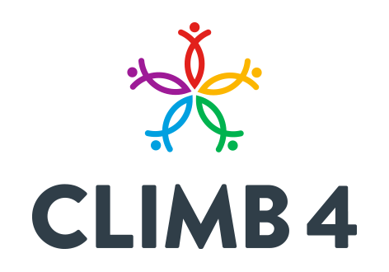
Climb 4 Referral Form
Please complete this form to the best of your ability and knowledge.
Information provided will help us to make informed decisions about we can support your service users
Referring Agency:
Name and address of Organisation:
Sector:
Contact Name and Number:
Contact email address:
Details about the person being referred:
Full name: | Date of Birth: Age:
Child/young persons Name (s) (if applicable)

Address: . | Contact number:
 | e-mail address:
Highlight which Climb 4 Programme do you think would support your service user/family further?
Arts for Health Green/Blue – Mindfulness nature activities, walks, arts and crafts.
Volunteer opportunities within the above programme.
Arts for health fit steps.
PAM- Positive Active Minds – Mental Health Peer Support Early Intervention service -Children, Young people and Family provision
STEPP up – Personal Development Training Programme
Benefits Information:
Why do you think the person will benefit from attending one of our programmes and being involved with Climb 4? Key outcomes

Supportive information/relevant history:
Is there any information we need to be aware of, to enable us to provide an appropriate safe service? E.g. Medical condition, mental health problems/conditions, Disability, SEN needs, additional support needed etc…

Name of Referrer Date Referred:
Internal Use:-

Service User contacted: Y/N Date:
If No – explain why
Which Service/Services referred onto?
Informed Referral Agency of progression onto one of our programmes Y/N

Any information provided will be protected by our Confidentiality and Data Protection Policy

