# Implementation of Direct Payment Cards

Issue 6 – January 2022

## In this Issue

• The latest position on the new system

• Confirmation of payee details

• Continuing Health Care update

**Any Questions?**

If you wish to discuss any concerns over the implementation of direct payment cards please call us on **0300 330 2910** or email   
[focus.mb-prepaidcardqueries@nhs.net](mailto:focus.mb-prepaidcardqueries@nhs.net?subject=Prepaid%20Cards%20Query)

Happy New Year to you all and welcome to the 6th newsletter about direct payment cards.

A lot has happened since our last newsletter. We hope this issue will bring you up to date.

**The latest position on the new system**

**Moving to the card system**

So far 82 direct payment users have moved to the new card system. All of the users that have moved so far have direct payments that are fully managed by PASS. The feedback on the process has been largely positive.

We plan to move the remainder of users who are fully managed by PASS next, and then those users supported by other organisations. When we move a user to the new card system we audit (check) the old account to make sure everything will be in place for the new account to run smoothly. The finance team are working very closely with PASS to make sure this happens.

**What we have learned from our audits**

The audits carried out as part of the process to move to card accounts are helping us to improve and shape the new system.

One thing we have noticed is the frequency with which client contributions to social care costs are being paid to the direct payment account. We would like to remind you to please pay your client contribution to your direct payment account on a 4-weekly basis. If this is not possible, please speak to the finance team’s visiting officer when they contact you about your financial audit, or your move to the card system.

**Know your customer (KYC) verification**

You might remember from a previous newsletter that the new card system requires us to verify (check) the indentity of people who receive a direct payment. This is a standard process used when new bank accounts are opened.

The KYC verification process is taking longer than we expected. We can’t avoid completing the KYC process, but we can try to make it as easy as possible for you. The finance team at focus will help you to make sure the KYC document is filled in correctly and in as little time as possible.

**Keeping your existing direct payment support organisation**

Some users have told us that they are worried they will lose their direct payment support organisation when moving to the card system. This is not the case. All arrangements that are in place to support you will remain the same for now.

We mentioned in a previous newsletter the delay to our plans to have a contract with organisations that help to manage a direct payment. We are not yet ready to set a new timetable for these plans. We will update you on the plans as soon as we can.

**Confirmation of payee: your bank**

A direct payment card account is a new account, separate from the bank account you previously used for your direct payment.

Once your move to a direct payment card account is complete, you will receive a letter from focus with your new account details.

If you pay a client contribution to the cost of your social care, you will be need to amend your current standing order details. Your contributions will need to be paid to your new card account instead of the account you paid them to previously.

Most users who have moved to a card account have set up their client contribution payments with no problems. However, a small number of users have received ‘payee does not match’ notifications from their bank.

This is because of the 'Confirmation of Payee' scheme set up by banks. The scheme means you can check whether the name you've been given matches the name associated with the account number and sort code you're paying money to. You can decide not to make the payment if you are concerned. Below is an example of what your bank may say:

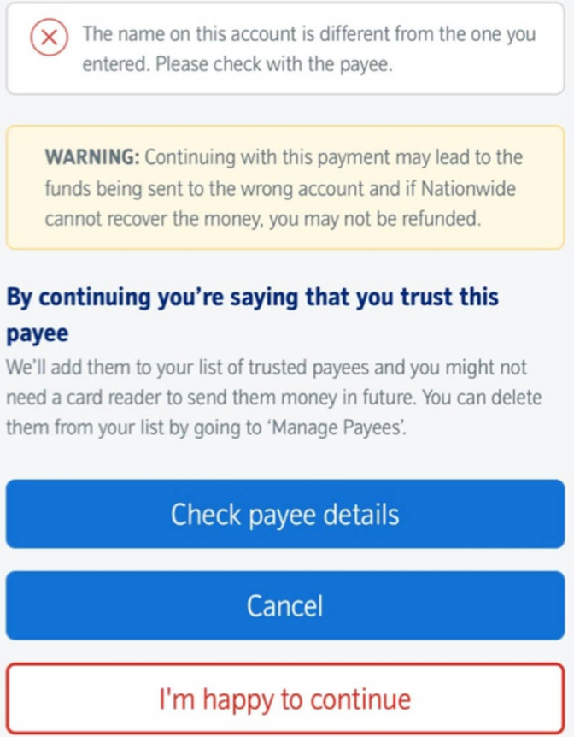

If you do receive this message please check the name, account number and sort code are correct before continuing with your payment. If you are worried please don’t hesitate to call the finance team so we can assist with setting up this payment. We are always here to help.

**Continuing Health Care Update**

Our plans for direct payment card accounts apply to users of social care, mental health after care and continuing healthcare (CHC). Our CHC team have given some positive feedback on the new card system.

They say: “*Continuing Healthcare (CHC) are delighted that direct payments are moving to using direct payment card accounts. We can see how this is going to be of great benefit to anyone with a Personal Health Budget. People will have more access to their account and we will be able to help them in a more efficient way. All the evidence required for the audit will be readily available and will therefore save people time and energy in preparing for that.”*

And finally….

If you want to discuss anything in this newsletter, please call us on   
0300 330 2910 or email   
[focus.mb-prepaidcardqueries@nhs.net](mailto:focus.mb-prepaidcardqueries@nhs.net?subject=Prepaid%20Cards%20Query)

All our newsletters, and other information on direct payments, are on our Live Well page: <https://livewell.nelincs.gov.uk/direct-payments/>

Organisations involved in this work are:   

EML - Money in Motion. This is the EML logo
