# Implementation of Direct Payment Cards

Issue 5 – September 2021

## In this Issue

• Getting to know the new system

• Direct payment card new name and look

• New leaflet(s)

**Any Questions?**

If you wish to discuss any concerns over the implementation of direct payment cards please call us on **0300 330 2910** or email   
[focus.mb-prepaidcardqueries@nhs.net](mailto:focus.mb-prepaidcardqueries@nhs.net?subject=Prepaid%20Cards%20Query)

Welcome to the fifth newsletter about the move to direct payment card accounts.

Thanks again for giving us your feedback after each newsletter. Your feedback is an important part of the changes we are making.

**Direct payment cards: getting to know the new system**

The Finance Team have started work to move the first group of people to direct payment card accounts. The first group of people to move will be those who have help from PASS/Care4all. The work is going well, and any issues we find are being ‘ironed out’ along the way.

We will send you a letter to confirm when it is your turn to move to the new system and explain how the process will work for you personally.

The process is a little different depending on how you manage your direct payment and what sort of help you have with it.   
  
We aim to work with you to adapt the process to meet your needs. We can also arrange a visit with you if you like.

In the meantime, we have been asked to explain some key things about how the card system works, and whether it is safe.

Some key things to know about your direct payment card account are:

* The direct payment card account is similar to online banking
* You can use the card account to make payments online, just like a normal bank account. For example, you could make payments to your personal assistant (PA) online
* Like a normal bank account, if you buy something online, the card system will prompt you to answer questions as part of the 3D secure payment verification process
* Unless we have agreed it with you, you will not be able to use the card to take cash out (the ATM function will be turned off)
* You will not be able to use the card to make contactless payments. The card can only be used with a PIN (personal identification number) to keep it secure
* We will make payments to the card account, in a similar way to how we make payments for you now
* If you contribute to the cost of your social care, this should be paid to the card account every 4 weeks.

We will talk you through the key things about the new card system when it is your turn to move to a direct payment card account.   
  
Please don’t worry that you will be left to work it out on your own; we are here to help.

**PrePaid Financial Services (PFS): new name and look**

You might remember from our second newsletter that our direct payment card account provider - PFS - is part of a wider company called EML.

The company is in the process of rebranding (changing how it looks). From now on, the company will use the name EML instead of PFS.

Direct payment monies will still be protected, and your contacts with the Finance Team at focus will stay the same.

The rebranding means that the direct payment cards will now look like this:

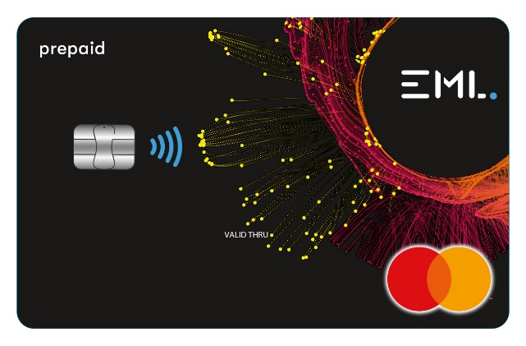

**A service user told us what they thought of the new design:**

The new card looks great. The dark background is ideal. It is much better than the old design and easier to read. Really, really pleased. Really Chuffed.   
  
This is a more inclusive design that will make a big difference to the visually impaired and suits a wider audience.

**Direct payment card agreements: new leaflet**

When you have a direct payment with us, we ask you to sign an agreement that sets out what we, and you, have promised to do.

In our last newsletter we explained that moving to direct payment card accounts gives us chance to look again at the agreement, and check that it has all the right things in it.

We have made some changes to the agreement to bring it up to date with our new ways of working. We explained some of those changes in our last newsletter.

We have also made different types of agreement. Which one we use depends on whether:

* you are able to decide for yourself to have a direct payment, or
* if you can’t decide about direct payments for yourself, someone else has made the decision for you.

We are making some new leaftets about the agreement. The leaflets give a summary of what is in each agreement. You should always read any agreement in full before you sign it, but we hope that the leaftets will help you to understand what you are signing.   
  
The leaflets will be on our Live Well page along with other information about direct payments.

If you want to discuss anything in this newsletter, please call us on   
0300 330 2910 or email   
[focus.mb-prepaidcardqueries@nhs.net](mailto:focus.mb-prepaidcardqueries@nhs.net?subject=Prepaid%20Cards%20Query)

All our newsletters, and other information on direct payments, are on our Live Well page: <https://livewell.nelincs.gov.uk/direct-payments/>

Organisations involved in this work are:  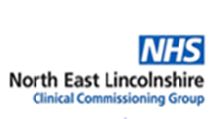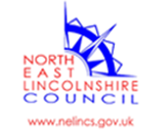 

EML - Money in Motion. This is the EML logo
